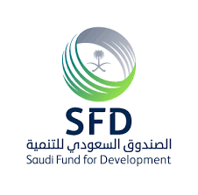
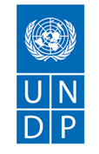
Progress Report

United Nations Development Programme Somalia
And Saudi Fund for Development

Project Title: Sustainable Access to Water for Rural Communities

Reporting date: 31 Dec 2025

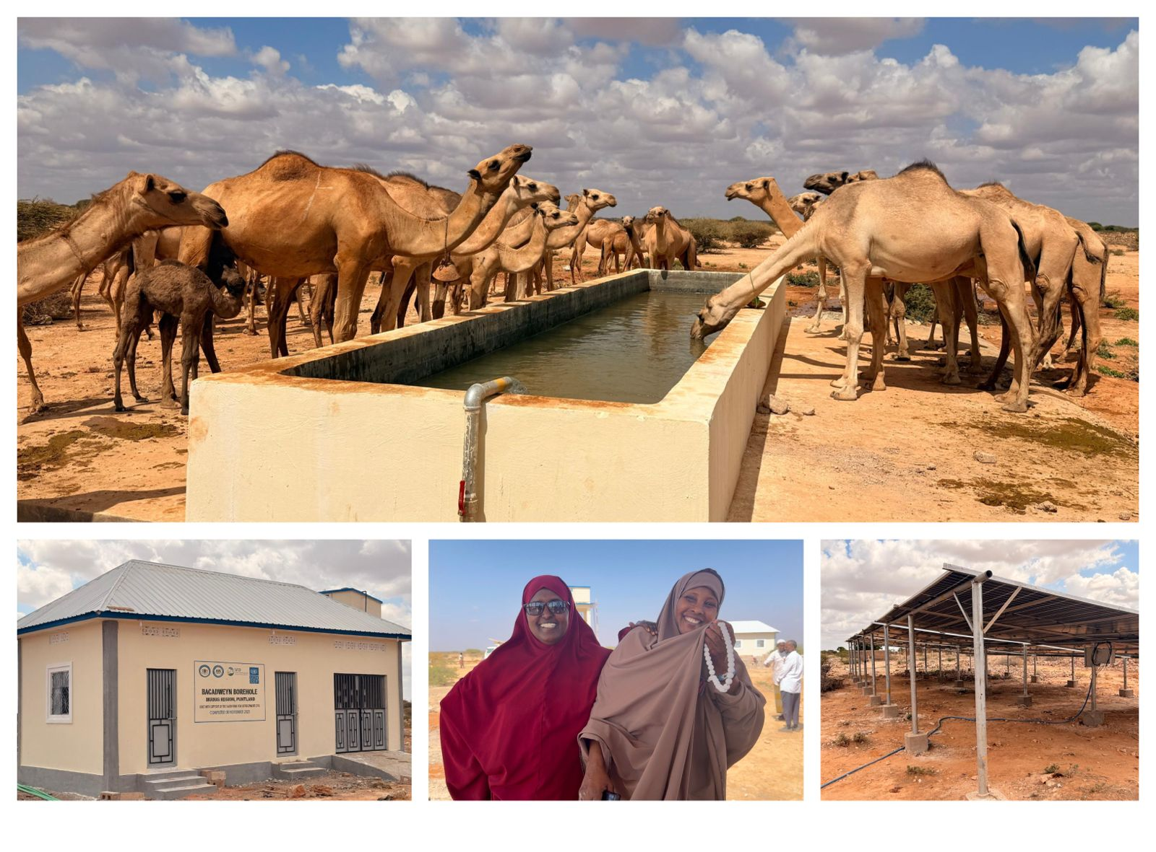

Reporting period: June -Dec 2025

Prepared by: Eng.Mohamed Abdisalam Aden

Reporting Period | June - Dec 2025
Donor | Saudi Fund for Development - SFD
Country | Somalia
Project Title | Sustainable Access to Water for Rural Communities
Project ID  (Atlas Award ID)  Output  (Atlas Project ID and Description)  Strategic Plan and/or CPD Outcomes | Quantum Project ID: 010004092
Implementing Partner(s) | UNDP
Project Start Date | 25 February 2025
Project End Date | 31 December 2026
Project Budget | USD $2,000,000.00
[Year] Annual Work Plan Budget 2025 (1st Tranche) | USD $920,883- – (The first tranche received end of May 2025)
Revenue received | - Regular USD  - Other  - Donor USD 900,000  - Total USD 900,000
UNDP Contact Person | Name of UNDP Signatory: Haoliang Xu  Title: United Nations Under Secretary General and UNDP Associate Administrator  UNDP Country Office: Somalia  UNDP Somali Team:  - Lionel Laurens, Resident Representative, Email: lionel.laurens@undp.org  - Christopher Laker, Deputy Resident Representative - Programme, Email: christopher.laker@undp.org  - Titus Kuuyuor, Portfolio Manager Reliance and Climate Change (RCC), Email: titus.kuuyuor@undp.org  - Mohamed Aden: Project Manager, Email: mohamed.aden@undp.org  - Maha Abusarma, Partnership & Gender Specialist, Email: maha.abusamra@undp.org  - Farah Alsweel, Regional Partnership Specialist, Email: farah.alsweel@undp.org

Table of Content
Contents
I. Executive summary 4
II. Background 5
III. Project Details 5
IV. Material and Resources 8
V. Quality Control 9
VI. Progress Review 10
VII. Project Risks and Issues 15
VIII. Work Planned for Next Period 16
IX. Lessons Learned 17
X. Environmental Considerations 18
XI. Conclusions and Way Forward 21
XII. Financial Status 22
XIII. Appendices 22

Executive summary

Brief Overview of the Project / Introduction
The Sustainable Access to Water for Rural Communities Project, funded by the Saudi Fund for Development (SFD) and implemented by UNDP Somalia, seeks to improve equitable access to clean water and strengthen community-led water governance systems in drought-affected regions of Somalia. Launched in June 2025 and scheduled to conclude in December 2026, the project aims to drill ten boreholes—four in 2025 and six in 2026—while establishing inclusive Water Resource User Associations (WRUAs) to ensure sustainability and resilience. This initiative aligns with Somalia’s National Development Plan (NDP-9) and UNDP’s resilience-building objectives, addressing chronic water scarcity and promoting gender-responsive governance.

Current Progress Status
During the reporting period of June to December 2025, the project remained broadly on track despite compressed timelines caused by the late release of funds in May 2025. Two boreholes—Bacadweyn and Awrboogays—were completed with full auxiliary works, while drilling advanced at Hagoogane and Qararo. The remaining boreholes are expected to be finalized by February 2026. Adaptive management strategies were adopted to mitigate delays, including revised drilling methodologies, strict contractor performance monitoring, and proactive stakeholder engagement.

Key Achievements and Issues
Key achievements include the completion of two boreholes and significant progress on two others, establishment and training of four inclusive WRUAs with 36 members, and delivery of gender-sensitive technical assessments and capacity-building sessions. Strong stakeholder engagement through consultations and legal land agreements reinforced community ownership and transparency. These efforts have already benefited drought-affected communities, reaching 46,000 direct beneficiaries and over 805,000 indirect beneficiaries.

However, the project faced several challenges. Compressed timelines placed pressure on procurement and implementation schedules, while geological complications at Hagoogane caused borehole collapses and increased operational costs. Contractor performance issues, including delays and contract termination in Qararo, further impacted delivery. Financial risk clauses such as “no water, no payment” discouraged some contractors, and logistical constraints in remote areas, coupled with security restrictions, limited direct engagement. Despite these obstacles, adaptive strategies and strong coordination helped maintain momentum and ensure quality standards.

Financial Summary (to be updated)
Total budget | 2,000,000.00
Revenue received | 900,000.00
Expenditure for reporting period | 775,063
Cumulative expenditure | 775,063
Delivery rate against budget | 86%

Background
Purpose of the Project
The Sustainable Access to Water for Rural Communities Project was initiated to address Somalia’s chronic water scarcity, which has been exacerbated by climate change, prolonged conflict, and weak institutional capacity. With less than 30% of the population having access to clean water, the project aims to provide reliable water sources to drought-affected communities, reduce the time and distance required to fetch water, and strengthen community-led governance systems. This intervention supports Somalia’s National Water Resource Strategy and aligns with UNDP’s resilience-building objectives, contributing to long-term water security and sustainable development.

Scope of Work
The project involves drilling ten boreholes across Somalia—four in 2025 and six in 2026—equipped with solar-powered pumping systems, elevated water tanks, kiosks, and animal troughs. Each borehole is designed to meet local hydrogeological conditions and ensure durability. The construction uses high-quality materials, including reinforced concrete for tanks and steel structures for kiosks, combined with solar technology to provide sustainable energy for water extraction. These systems aim to deliver safe water for domestic use, livestock, and small-scale irrigation, reducing reliance on seasonal and unsafe water sources

Project Objectives
The objectives of the project are to improve equitable access to clean and safe water for rural communities, establish inclusive Water Resource User Associations (WRUAs) to manage water infrastructure and promote gender-responsive governance, and enhance community capacity through training in operations, maintenance, and financial management. Additionally, the project seeks to foster resilience by integrating sustainable technologies such as solar-powered systems and promoting community ownership of water resources. By addressing immediate humanitarian needs and building long-term resilience, the project contributes to Somalia’s broader goals of peacebuilding, resilience, and sustainable development.

Project Details
In 2025, UNDP planned to drill four boreholes located across the Federal Member States of Puntland and Northeastern State of Somalia. In Puntland, the borehole was drilled in Bacadweyn village, while in Northeastern State, boreholes were drilled in Awrboogays, Qararo, and Hagoogane villages. The details and information for each project are outlined below.

Bacadweyn Water Borehole
The Bacadweyn Borehole Project is located in Bacadweyn village, Galkacayo District, Mudug Region of Somalia. The scope of work includes drilling a borehole, conducting well development and pump testing, and constructing auxiliary water supply infrastructure such as an elevated water tank, animal troughs, a kiosk, a guard room, and a solar-powered pumping system. These works aim to provide sustainable access to clean water for the local community.
According to the contract, the contractor is required to commence work within seven days of receiving site access and the notice to proceed. The entire project is scheduled for completion within eight weeks, which translates to approximately two months. The timeline includes all drilling operations, installation of casings and screens, development works, and testing to ensure compliance with technical specifications. Any delays beyond the agreed period will attract liquidated damages of 0.5% of the contract price per week, up to a maximum of 10%. To maintain progress, the contractor must submit a detailed Programme of Work by 18 September 2025 and adhere to UNDP’s supervision and quality standards.
The fixed contract value for the Bacadweyn Borehole Project is USD 114,371.23 Payment will be made in three installments: 40% upon completion of 50% of the work, 50% upon full completion of all works, and the remaining 10% after the 12-month defects liability period. The contract specifies that no price adjustments will be allowed for currency fluctuations or changes in market conditions. All payments will be processed upon certification by the supervising engineer, ensuring that the work meets the required standards.

Awrboogays Water Borehole
The Awrboogays Water Borehole Project is located in Awrboogays village, Xudun District, Sool Region of Somalia. The project aims to provide sustainable access to clean water for the local community through the construction of a borehole and associated water supply infrastructure. The scope of work includes conducting a geophysical survey to identify a suitable drilling site, mobilizing drilling equipment and personnel, and drilling a borehole with a finished-cased diameter of 12 to 18 inches. The contractor will install PVC casing and screens, a gravel pack, and a sanitary seal to ensure water quality and structural integrity. Borehole development will be carried out to maximize yield, followed by a 24–72-hour pump test to determine discharge capacity and aquifer properties. Water samples will be analyzed for physical, chemical, and bacteriological parameters to confirm compliance with standards.
In addition to the borehole, the project includes the construction of auxiliary structures such as an elevated water tank, two animal troughs, a kiosk, a guard room, and a solar-powered pumping system. A complete piping network will connect these components to ensure efficient water distribution. The contractor is required to submit detailed reports, including a borehole completion report, pump test results, and water quality analysis. All works must meet UNDP technical specifications and quality standards.
The contract was awarded to Najax Supply and Construction Company for a fixed price of USD 106641.8. The implementation period is eight weeks from site handover. Payments will be made in three installments: 40% upon completion of 50% of the works, 50% upon full completion, and the remaining 10% after a 12-month defects liability period. Liquidated damages of 0.5% of the contract price per week apply for delays, up to a maximum of 10%. Upon completion, the system will be handed over to UNDP, the Ministry of Water and Energy, and community representatives.

Qararo Water Borehole
The Qararo Water Borehole Project is located in Qararo village, Buuhoodle District, Cayn Region of Somalia. The project aims to provide sustainable access to clean water for the local community through the drilling of a borehole and the construction of auxiliary water supply infrastructure. The scope of work includes borehole drilling, installation of PVC casing and screens, gravel packing, sanitary sealing, and well development to ensure maximum yield and water quality. A comprehensive pump test will be conducted to determine the discharge capacity and aquifer properties, followed by water quality analysis to meet physical, chemical, and bacteriological standards. In addition to the borehole, the project involves constructing an elevated water tank, animal troughs, a kiosk, a guard room, and installing a solar-powered pumping system with a complete piping network.
The contract was awarded to Najax Supply and Construction Company for a fixed price of USD 159,522.01. The contractor is required to commence work within 14 days of site handover and complete all works within 8 weeks. Payments will be made in three installments: 40% upon completion of 50% of the works, 50% upon full completion, and the remaining 10% after a 12-month defects liability period. A government levy of 3% applies to the contract. Liquidated damages for delay are set at 0.5% of the contract price per week, up to a maximum of 10%. All works must comply with UNDP technical specifications and quality standards, and the contractor is responsible for repairing any defects during the liability period at their own cost.
Upon completion, the system will be handed over to UNDP, the Ministry of Water and Energy, and community representatives. The project is expected to significantly improve water access and resilience for the Qararo community.

Hagoogane Water Borehole
The Hagoogane Water Borehole Project is located in Buuhoodle District, Cayn Region of Somalia. The project aims to provide sustainable access to clean water for the local community through the construction of a borehole and associated water supply infrastructure. The scope of work includes conducting a geophysical survey to identify a suitable drilling site, mobilizing drilling equipment and personnel, and drilling a borehole with a finished-cased diameter of 12 to 18 inches. The contractor will install PVC casing and screens, a gravel pack, and a sanitary seal to ensure water quality and structural integrity. Borehole development will be carried out to maximize yield, followed by a 24–72-hour pump test to determine discharge capacity and aquifer properties. Water samples will be analyzed for physical, chemical, and bacteriological parameters to confirm compliance with standards.
In addition to the borehole, the project includes the construction of auxiliary structures such as an elevated water tank, two animal troughs, a kiosk, a guard room, and a solar-powered pumping system. A complete piping network will connect these components to ensure efficient water distribution. The contractor is required to submit detailed reports, including a borehole completion report, pump test results, and water quality analysis. All works must meet UNDP technical specifications and quality standards.
The contract was awarded to Rehan Logistics and Trading Company for a fixed price of USD $155,146.50. The implementation period is eight weeks from site handover. Payments will be made in three installments: 40% upon completion of 50% of the works 50% upon full completion and the remaining 10% after a 12-month defects liability period. Liquidated damages of 0.5% of the contract price per week apply for delays, up to a maximum of 10%. Upon completion, the system will be handed over to UNDP, the Ministry of Water and Energy, and community representatives.

UNDP Borehole Projects – 2025 Summary
Project Location | Region/District | Contractor | Contract Value (USD) | Duration | Payment Terms | Liquidated Damages
Bacadweyn  Village | Mudug / Galkacayo | Najax Supply & Construction Co. | 114,371.23 | 8 weeks | 40% at 50% completion, 50% at full completion, 10% after 12-month defects liability | 0.5% per week, max 10%
Awrboogays  village | Sool / Xudun | Najax Supply & Construction Co. | 106,641.80 | 8 weeks | 40% at 50% completion, 50% at full completion, 10% after 12-month defects liability | 0.5% per week, max 10%
Qararo  Village | Cayn / Buuhoodle | Najax Supply & Construction Co. | 159,522.01 | 8 weeks | 40% at 50% completion, 50% at full completion, 10% after 12-month defects liability | 0.5% per week, max 10%
Hagoogane  Village | Cayn / Buuhoodle | Rehan Logistics & Trading Co. | 155,146.50 | 8 weeks | 40% at 50% completion, 50% at full completion, 10% after 12-month defects liability | 0.5% per week, max 10%

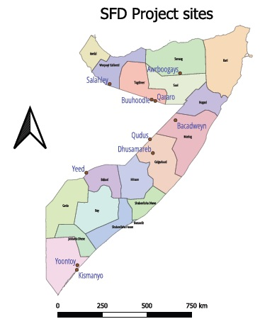

Material and Resources
Introduction
This report consolidates the material requirements for borehole drilling and associated civil works across four sites: Hagoogane, Qararo, Awrboogays, and Bacadweyn. These sites share similar hydrogeological conditions and design specifications, enabling standardization of materials and efficient procurement planning. The scope includes borehole drilling and well development, construction of operation offices and generator rooms, elevated reinforced concrete water tanks, animal watering troughs, water collection kiosks, and solar pumping systems.

Borehole Drilling and Well Works
All sites require drilling fluid and bentonite for sealing, uPVC casing pipes (8-inch, blue color), and uPVC well screens with 1 mm slots. Grouting between the inner and outer casing and gravel filter backfill made of siliceous rock are included. Electrical materials consist of water-resistant cables and rising mains: stainless steel rising mains (SS 304/316, 2-inch diameter) for Hagoogane and Qararo, and uPVC rising mains for Awrboogays (2-inch sections) and Bacadweyn (3-inch sections). Submersible pumps and motors (Lowara type) are provided at each site, along with mass concrete for borehole headworks and disinfection chemicals for chlorination.

Operation Office, Store, and Generator Room
Each site requires concrete for blinding layers, slabs, beams, and columns, rubble stone for foundations, and hardcore filling. Masonry cement block walling covers significant areas, complemented by ventilation hollow blocks. Finishes include ceramic floor tiles, wall skirting tiles, and plastering with cement-sand mix. Roofing uses galvanized iron sheets supported by timber trusses, and ceilings are finished with laminated boards. Fascia boards, steel doors, and steel windows are installed for security. Electrical wiring systems with fixtures and main switchboards complete the setup.

Elevated RCC Water Tank
The elevated water tank construction involves reinforced concrete for footings, beams, columns, slabs, and walls, along with rubble stone for the foundation. Waterproofing is applied to internal surfaces, and painting covers external areas. Additional materials include inspection manhole covers with BS mesh A142, galvanized iron pipes (2-inch, class B) for inlet and outlet connections, and metallic ladders for access

Animal Troughs (Camel and Goat/Sheep)
Camel and goat/sheep troughs at all sites use similar materials: plain concrete blinding, reinforced concrete slabs, rubble stone walls, hardcore filling, and masonry block walling. Plastering is applied to internal and external surfaces, and galvanized steel piping systems are installed for water inlet, outlet, and overflow.

Water Collection Kiosk
Kiosks require concrete slabs and walkways, galvanized iron poles (3-inch diameter, 3 meters high) anchored in concrete, masonry block walls, and hardcore filling. Roofing consists of galvanized iron sheets with timber trusses, and ceilings use laminated boards. Plastering and painting are applied to all surfaces for durability.

Solar Pumping System
Solar systems across the sites include photovoltaic modules (550 W panels), solar inverters and control units, and support structures for mounting panels. Electrical accessories include submersible drop cables, underground cables, and earthing sets. Additional fittings include uPVC borehole pipes, gate valves, non-return valves, float switches, borehole covers, water meters, and splicing kits. Installation sundries and anchoring components complete the system.

Conclusion
The merged material schedule demonstrates significant overlap across all four sites, enabling bulk procurement and cost efficiency. Standardization of key items such as uPVC casing, reinforced concrete works, masonry blocks, roofing sheets, and solar components ensures uniform quality and simplifies logistics. Minor variations, such as rising main specifications and solar panel counts, have been accounted for. This consolidated approach supports streamlined implementation, reduced duplication, and improved resource management.

Quality Control
Ensuring Work Quality and Delivering High-Quality Outputs
Quality assurance is achieved by ensuring that the contractor strictly adheres to the Bill of Quantities (BoQs), designs, and contract terms as outlined in the agreements. In addition, once the work is verified, it is mandatory that all key stakeholders approve, including the Ministry of Water, Energy, and Minerals of member states, UNDP, the Federal Ministry of Water and Energy of Somalia, and the beneficiary community. These stakeholders play a major role in the preparation of BoQs, designs, and site selection.
Furthermore, the final bill of materials is presented, detailing all components of the work and the materials to be used. At the same time, we ensure that any concerns or recommendations from stakeholders are addressed and necessary adjustments are made before and during implementation. Ultimately, customer satisfaction is our core principle of quality control.

Payment Conditions.
The contract specifies that once all stakeholders approve the work, 40% of the payment is released to the contractor. Another 50% is paid upon completion of the work, and the remaining 10% is released after 12 months of monitoring the borehole to ensure no defects occur. If any defect arises that is not caused by human error or negligence, the contractor is required to rectify the issue, whether it relates to quality or any other technical problem.

Work Process
The work begins with drilling the borehole. Once water is found, pipes, pump, and casing are installed and tested for 24 hours under the supervision of the Water User Association. Afterwards, UNDP and the Ministry of Water, Energy, and Minerals of member states conduct their own testing. Only then is the initial 40% payment released. Our agreement with all contractors is based on the principle: “No Water, No Payment.”

Inspection Process
Once the contractor is awarded the contract, UNDP and all relevant ministries jointly travel to the project site. During this joint visit, the team conducts an orientation session for the contractor, Water User Associations, and community elders. The session covers the scope of work, processes, milestones, contract terms, duration of the work, BoQs, and designs.
After the orientation, the Water User Association nominates representatives who will work closely with the contractor and oversee the progress of the work as agreed. Subsequently, the site is officially handed over to the contractor.
From the handover onwards, the inspection process is carried out in three stages:
- When the contractor officially reports that 50% of the work is completed, an inspection is conducted to approve the release of 40% of the payment.
- When the contractor officially reports that 100% of the work is completed, an inspection is conducted to approve the release of 50% of the payment.
- After 12 months from the completion date, a final inspection is conducted to confirm the quality and functionality of the work before releasing the remaining 10% of the payment.
In addition to these three scheduled inspections, any challenges or issues that arise during the project are jointly addressed through site visits to resolve them promptly.

Progress Review
This progress review provides an overview of key achievements under the project aimed at improving access to sustainable water resources and strengthening local capacity for water governance in targeted communities. The report highlights milestones reached in infrastructure development, stakeholder engagement, and institutional capacity building, reflecting the project’s commitment to inclusive and sustainable solutions for water security
Extensive stakeholder consultations were successfully conducted in Qararo, Awrboogays, Bacadweyn, and Shangeed/Hagoogane. Each session engaged approximately 50 participants representing diverse community groups, including elders, women, youth, and marginalized populations. These workshops validated priority water needs and ensured that the project design reflects local realities and community priorities. The inclusive approach strengthened trust and ownership among stakeholders, laying a solid foundation for subsequent implementation phases.

Following consultations, site selection and land formalization were completed through legally binding agreements with community representatives. These agreements secured community ownership and provided legal clarity for borehole development, mitigating potential land disputes. This step was critical for ensuring sustainability and accountability, as communities now have a vested interest in protecting and maintaining the water infrastructure.
Engineering designs and Bills of Quantities (BoQs) for the four boreholes were finalized and uploaded to UNALL, UNDP’s internal procurement and logistics system. This milestone marked the transition from planning to execution, enabling procurement processes to commence. The designs incorporated technical specifications tailored to local hydrogeological conditions, ensuring efficiency and durability of the water systems.
The procurement process for the borehole project was successfully completed, and contracts were awarded for all four boreholes. Formal site handovers were conducted with contractors, ensuring clarity on roles, timelines, and quality standards. This achievement reflects strong coordination between UNDP, local authorities, and vendors, accelerating progress toward tangible water access improvements.
Construction activities are well underway, with two boreholes—Bacadweyn and Awrboogays—already completed. The remaining two boreholes in Qararo and Hagoogane are in advanced stages and are expected to be finalized by February 2026. This progress demonstrates effective project management and adherence to timelines despite logistical challenges in remote areas.
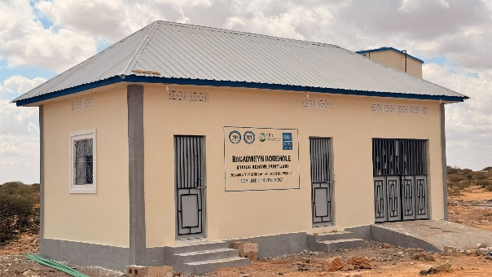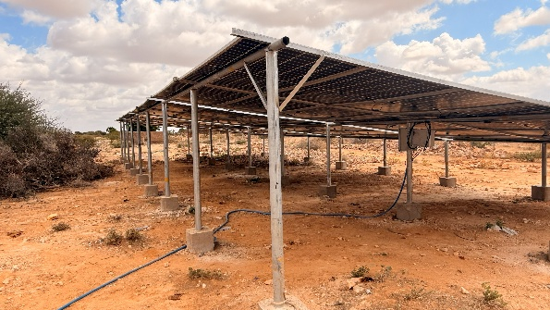
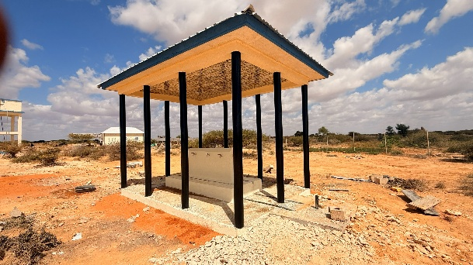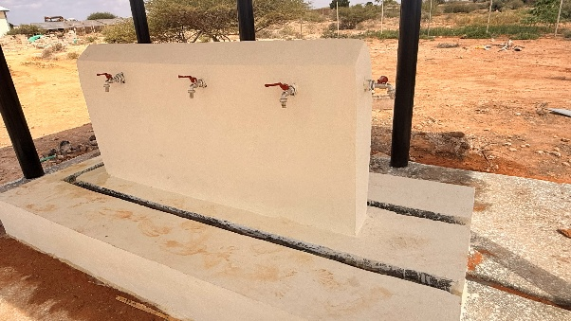
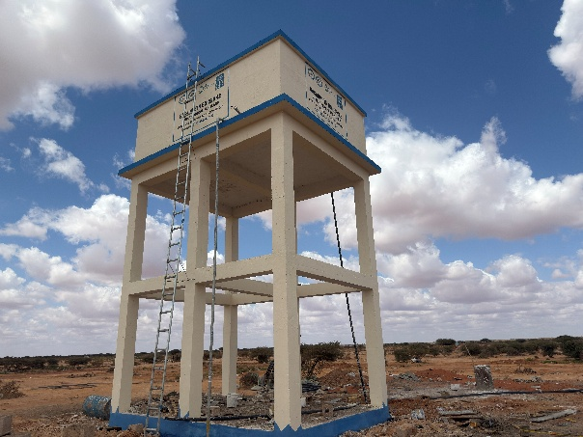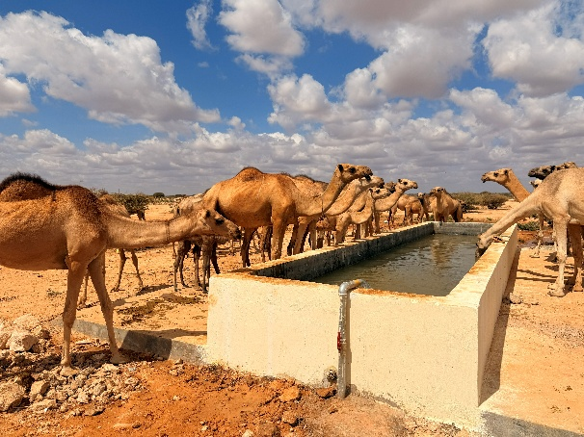
Figure1: Bacadweyn water borehole ( Elevated water tank, Trough, Solar system, Office and kiosk courtesy to UNDP Somalia, 4 Dec 2025
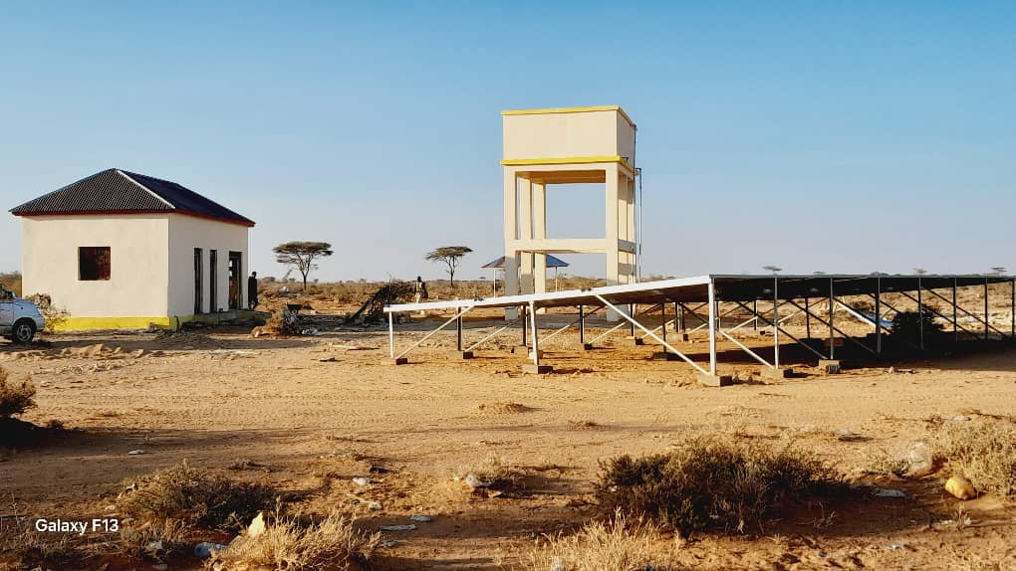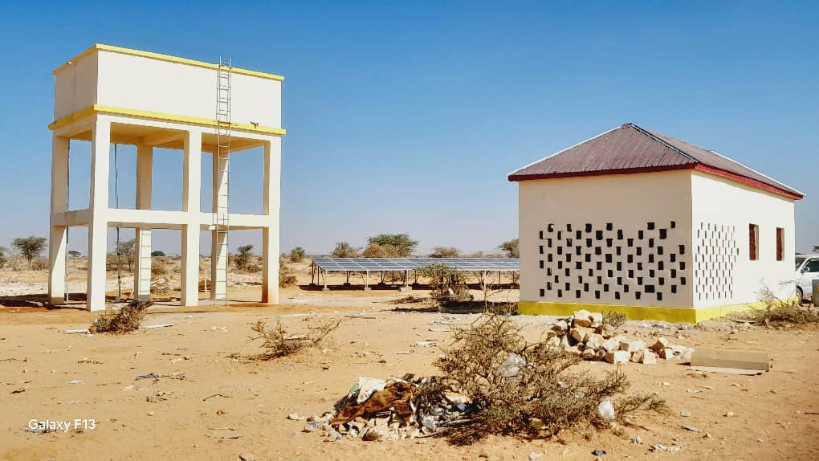
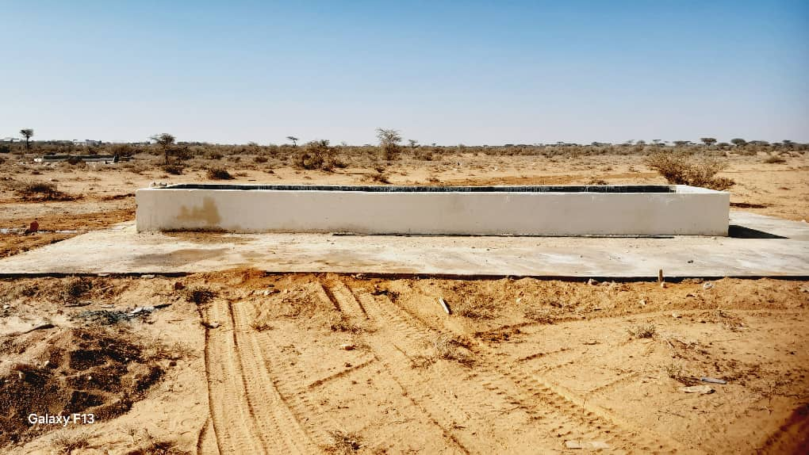
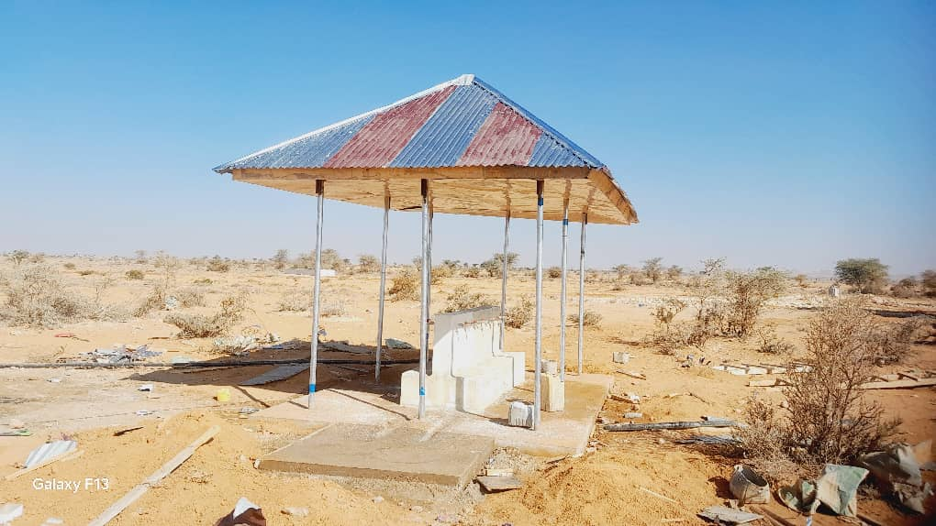
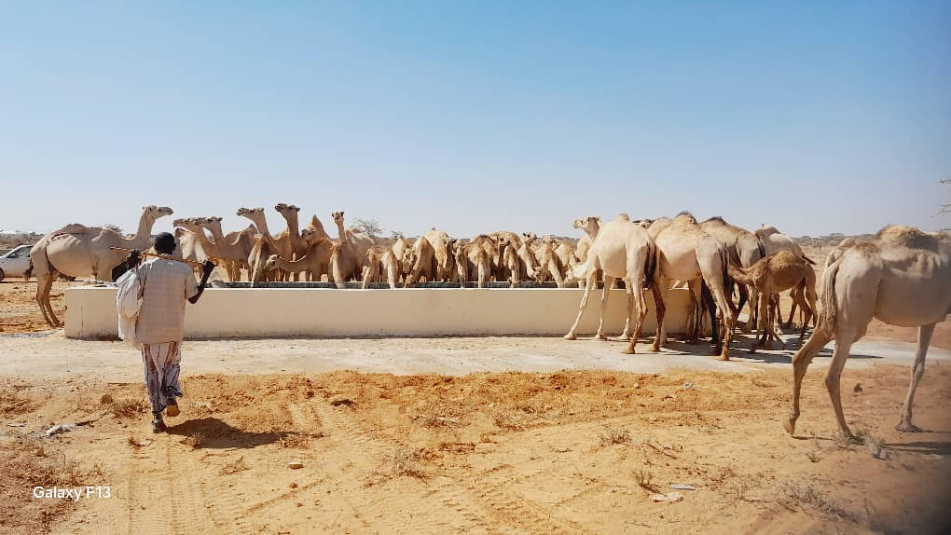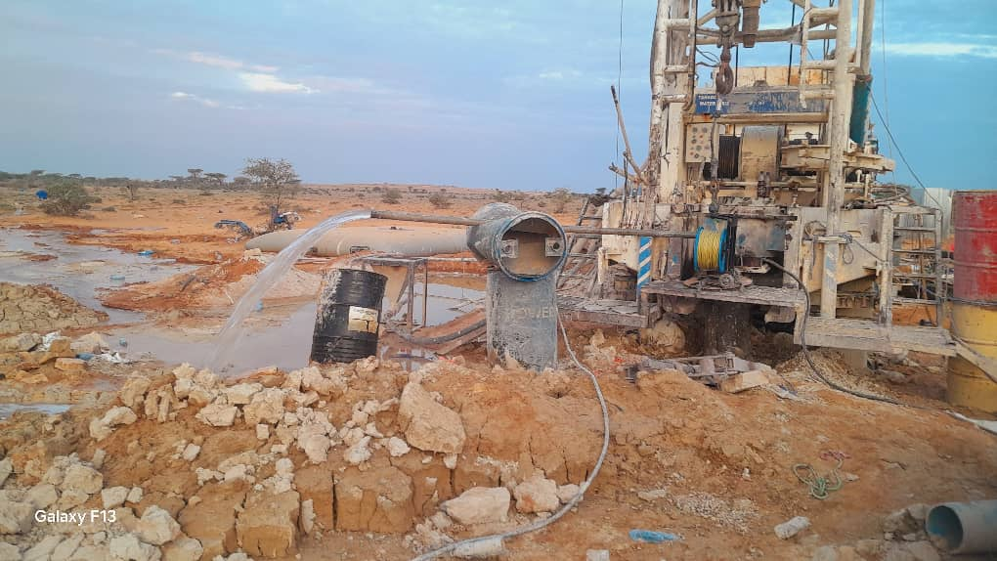
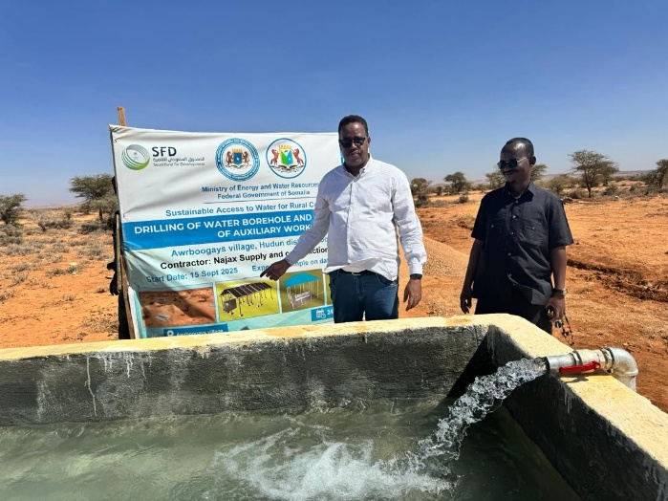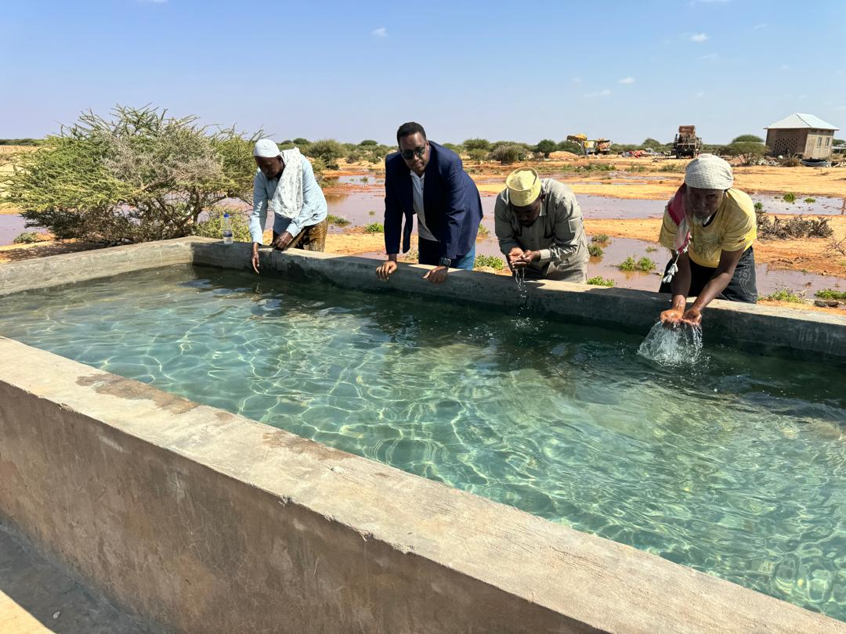
Figure 2: Awrboogays Water Borehole (Elevated water tank, Trough, Solar system, Office and kiosk), courtesy to UNDP Somalia, 7 Dec2025
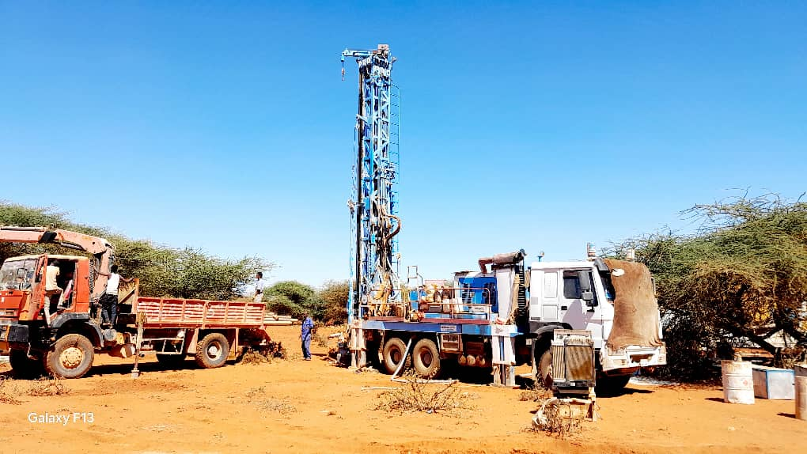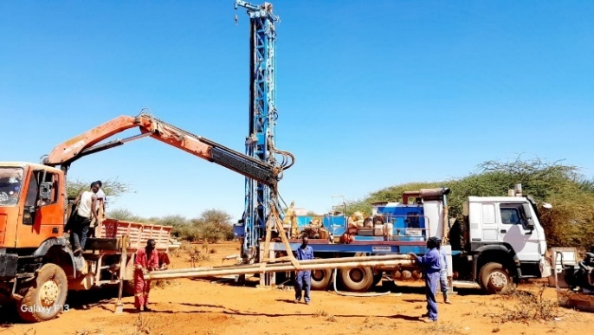
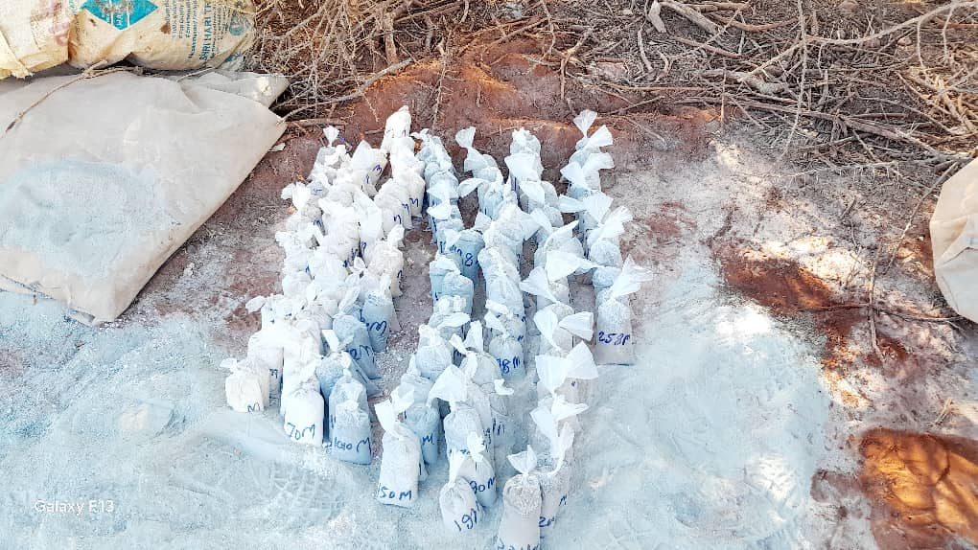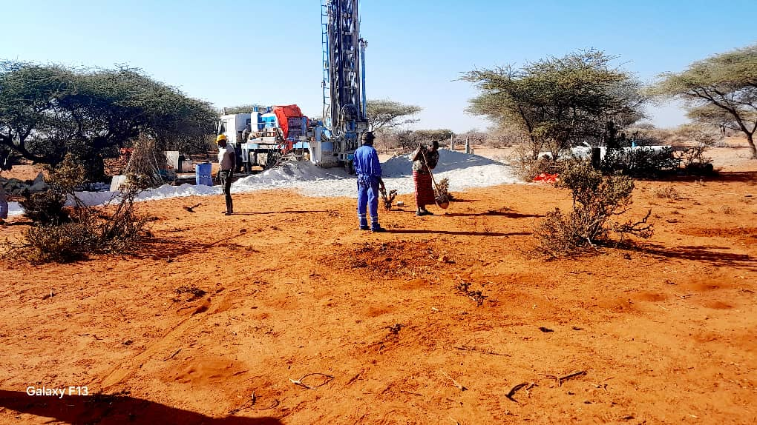
Figure 4: Qararo Water Borehole and capacity building for WUAs), courtesy to UNDP Somalia, 4 Jan 2026
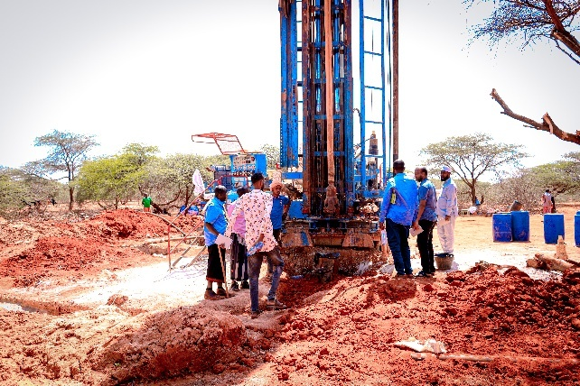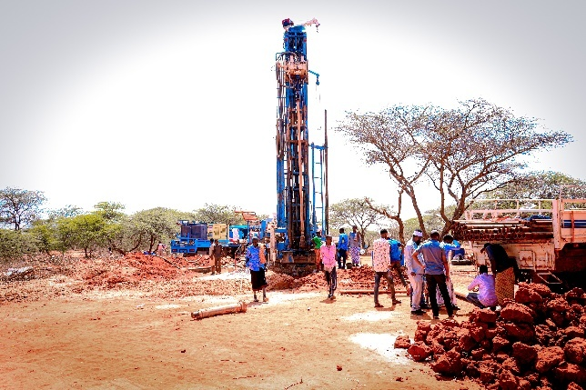
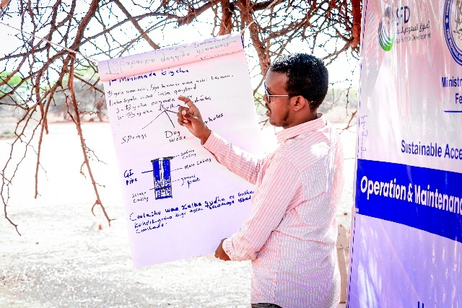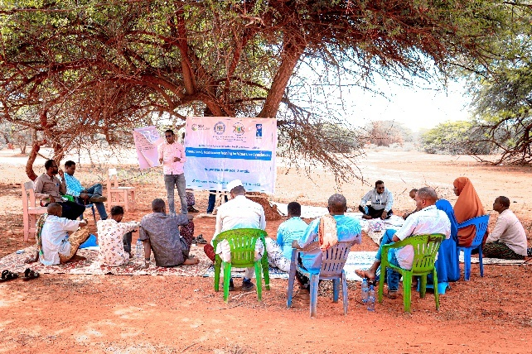

Figure 3: Hagoogane Water Borehole and capacity building for WUAs), courtesy to UNDP Somalia, 9 Dec2025

Comprehensive orientation sessions were organized for contractors, Water User Associations (WUAs), and community elders, including women representatives. These sessions ensured alignment with project objectives, technical standards, and operational procedures. Additionally, full site layouts and technical drawings were translated into Somali and shared with WUAs, empowering local actors to monitor and support implementation effectively.
Inclusive Water Resource User Associations (WRUAs) were established in all four project locations: Qararo (10 members), Awrboogays (9 members), Bacadweyn (6 members), and Hagoogane (13 members), totaling 36 members. These associations include women, youth, and marginalized groups, ensuring equitable participation in water governance and fostering community-led management of borehole infrastructure.
Comprehensive gender-sensitive technical assessments were conducted to identify disparities in water access, decision-making, and operational capacity. Findings highlighted systemic barriers faced by women and vulnerable groups, informing strategies to promote inclusivity and equitable resource distribution. These assessments will guide future interventions and advocacy efforts.
Targeted capacity-building sessions were delivered to all 36 WRUA members, equipping them with skills in governance, financial management, and technical oversight. Training emphasized sustainability, accountability, and gender equity, ensuring that local institutions are prepared to manage water resources effectively post-project.
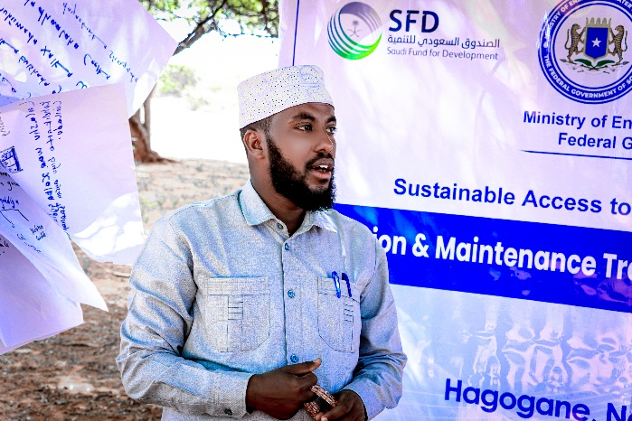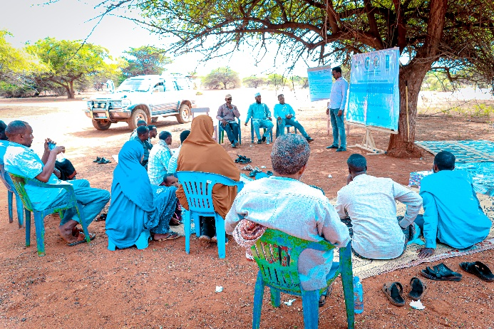
Photos 01: Hagoogane WUAs training, Courtesy to UNDP Somalia on 11 Nov 2025
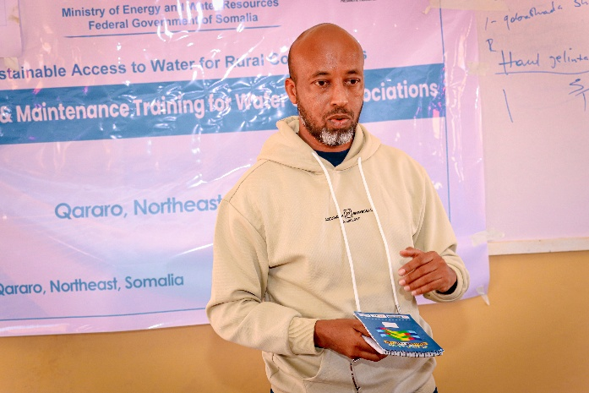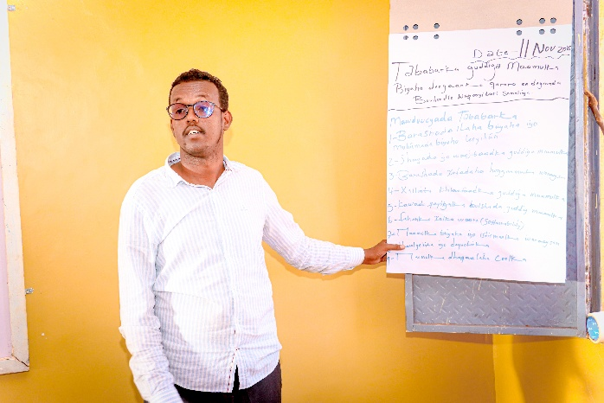
Photos 02: Qararo WUAs training, Courtesy to UNDP somalia on 12 Nov 2025
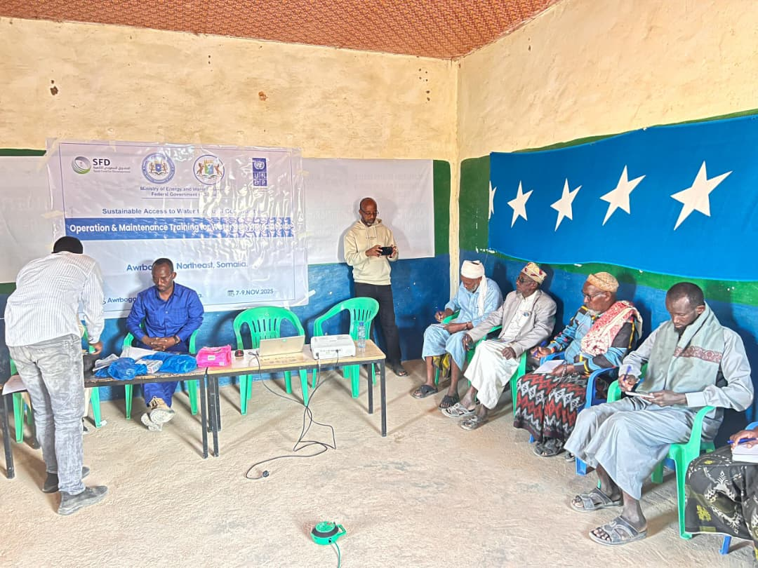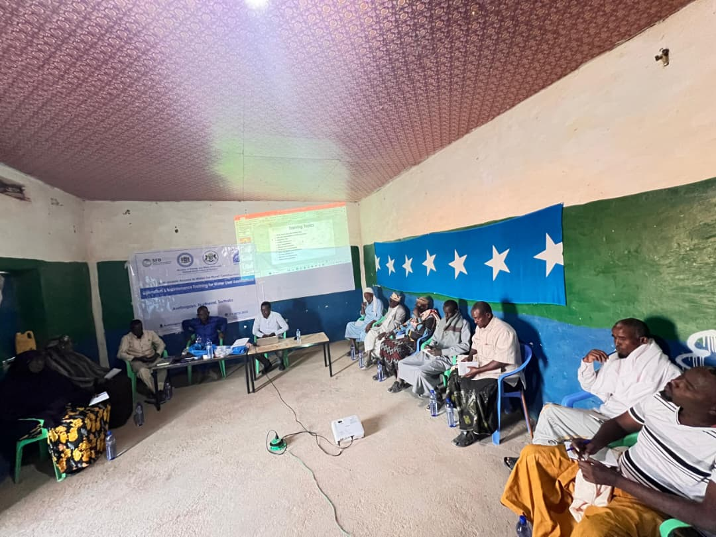
Photos 03: Awrboogays WUAs Training, Courtesy to UNDP Somalia on 8th Nov 2025
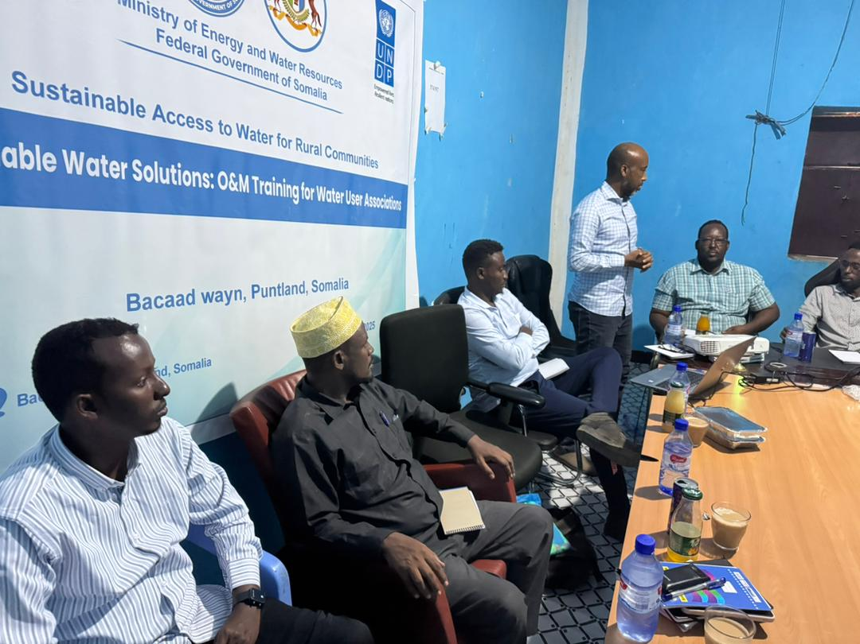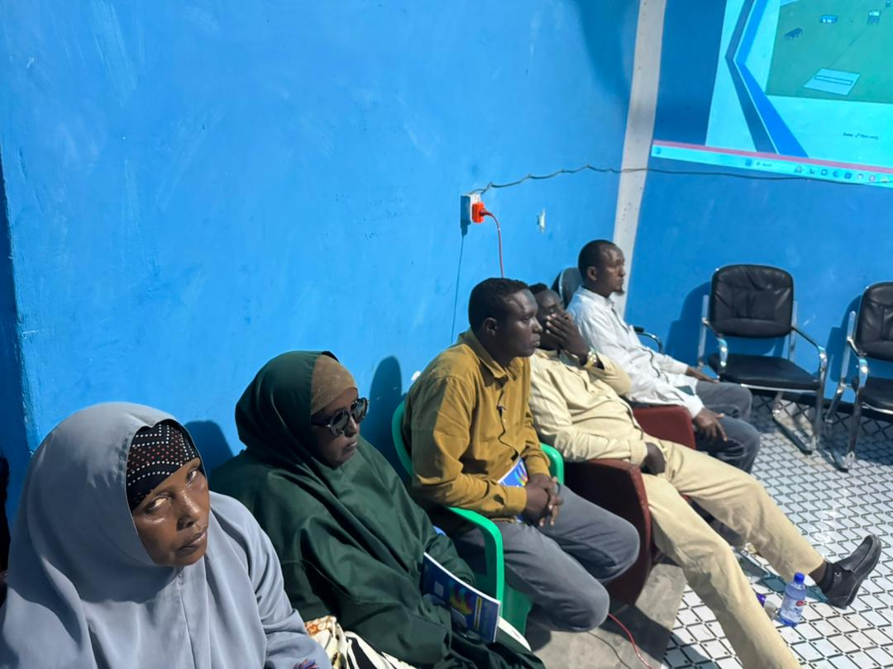
Photos 04: Bacadweyn WUA Training, Courtesy to UNDP Somalia on 4 Nov 2025

The project team conducted a field mission from 2 to 10 December 2025, led by Omar Artan who is the coordinator for Saudi Fund for Development project (Sustainable Access to Water for Rural Communities) to verify and monitor project progress. During the mission, the team visited water borehole sites in Bacadweyn, Awrboogays, Hagoogane, and Qararo, and engaged with both community members and Water User Associations to assess the status and functionality of each water infrastructure.
Preparations for advocacy campaigns and awareness-raising activities are underway, scheduled to commence after the completion and handover of all four boreholes.

The project has made significant strides in improving water access and strengthening governance structures. Two boreholes are operational, and two are ongoing, ensuring timely delivery of infrastructure. WRUAs have been formed and trained, promoting inclusive and sustainable water management. Gender-sensitive assessments and upcoming advocacy campaigns will further enhance equity and community ownership. Overall, the initiative is on track to achieve its objectives by early 2026, contributing to long-term water security and resilience in the target community.
Progress Against Outputs and Indicators

Output 1: Access to Sustainable Water Resources
Access to sustainable water resources is a critical component of improving resilience and livelihoods in drought-affected communities. Under this output, the project focused on addressing severe water scarcity through a comprehensive approach that included stakeholder consultations, engineering design, procurement, and construction of water facilities. By engaging communities in participatory planning, formalizing land agreements, and ensuring technical readiness, the initiative aimed to deliver reliable water infrastructure while promoting transparency and community ownership. These efforts are complemented by ongoing construction and orientation activities, ensuring that water systems are not only operational but also managed effectively for long-term sustainability.

Indicator | Baseline | Target (2025) | Actually (July-Dec) Completed | Source of Verification
1.1 Stakeholder consultations conducted | 0 | 4 | 4 | Back to office report, Reports, attendance sheet
1.2 Engineering designs completed | 0 | 4 | 4 | Design documents, Bill of Quantities.
1.3 Tenders issued | 0 | 4 | 4 | Procurement records
1.4 Water facilities constructed/drilled | 0 | 4 | 2 are completed and 2 are ongoing on | Reports, certifications and payments

Achievements to end Dec 2025
Stakeholder consultations were conducted between June 13 and June 30, 2025, targeted drought-affected communities in Qararo, Shangeed, Bacadweyn, and Owrbogeys as part of the “Sustainable Access to Water for Rural Communities” project, jointly implemented by UNDP and the Ministry of Energy and Water Resources with support from the Saudi Fund for Development. The mission aimed to address severe water scarcity through stakeholder engagement, community consultations, site selection for boreholes, and the establishment of Water User Associations (WUAs). Consultations revealed acute water shortages, forcing women and children to travel long distances for water, and highlighted the urgent need for boreholes, water kiosks, tanks, animal troughs, and solar-powered systems.

Inclusive WUAs were established in all four locations to promote sustainable water governance, with representation from women, youth, and marginalized groups. These associations will oversee borehole management, maintenance, and equitable water distribution. The mission also identified significant capacity gaps in operation and maintenance, emphasizing the need for technical training and provision of spare parts. Site selection and land acquisition were completed through formal agreements, ensuring transparency and community ownership of the borehole sites. GPS mapping and ArcGIS technology were used to validate locations, and legal documentation was finalized to secure public land for water infrastructure.

Site selection and land formalization were finalized through signed agreements, securing community ownership and providing legal clarity for borehole development.

Engineering designs and Bills of Quantities (BoQs) for the four boreholes were completed and uploaded to UNALL (UNDP’s internal procurement and logistics system), paving the way for procurement.

The procurement process for the borehole project has been completed, and contracts have been awarded for all four boreholes. All project sites have been formally handed over to the respective contractors, who have now commenced borehole drilling and auxiliary construction works.

2 boreholes ( Bacadweyn and Awrboogays boreholes) are completed, and 2 boreholes (Qararo and Hagoogane boreholes) are ongoing. The remaining boreholes are expected to be finalized Feb 2026.

Comprehensive orientation sessions were held for contractors, Water User Associations, and community elders—including women representatives—to ensure all stakeholders are aligned with project objectives and procedures. Furthermore, full site layouts and technical drawings, translated into Somali, were provided to the Water User Associations to support effective implementation and monitoring throughout the execution phase.

Output 2: Strengthened Local Capacity for Water Governance
Strengthening local capacity for water governance is a cornerstone of ensuring sustainable water resource management in drought-affected communities. Under this output, the project focused on empowering community institutions through inclusive governance structures, technical assessments, and capacity-building initiatives. By establishing Water Resource User Associations (WRUAs), conducting gender-sensitive assessments, and delivering targeted training sessions, the project aimed to promote equitable participation and enhance operational efficiency. These efforts are complemented by planned advocacy campaigns to raise awareness and reinforce community ownership, ensuring that water governance systems remain resilient and responsive to local needs.

Indicator | Baseline | Target (2025) | Actually (July-Dec) completed | Source of Verification
2.1 Gender-sensitive assessments conducted | 0 | 4 | 4 | Assessment reports
2.2 WRUAs established or strengthened | 0 | 4 | 4 | TORs & Report
2.3 Training sessions conducted | 0 | 4 | 4 | Attendance sheets, evaluations
2.4 Advocacy campaigns conducted | 0 | 4 | 0 | Campaign reports

Achievements
As part of the project’s commitment to participatory water governance, four inclusive Water Resource User Associations (WRUAs) were successfully established in Qararo, Awrboogays, Bacadweyn, and Hagoogane. These associations were formed through a consultative process that prioritized representation from all segments of the community, including women, youth, and marginalized groups, ensuring that decision-making reflects diverse perspectives and needs. Each WRUA was provided with clear Terms of Reference and structured roles to oversee borehole management, equitable water distribution, and conflict resolution related to water use. The establishment of these associations marks a significant step toward local ownership and sustainability, as they serve as the primary governance bodies responsible for operation and maintenance of water infrastructure. By embedding inclusivity and accountability into their structure, WRUAs are positioned to strengthen resilience, promote transparency, and foster community-driven solutions for long-term water security.

As part of efforts to promote inclusive water governance, the project conducted four comprehensive gender-sensitive technical assessments across the target communities of Qararo, Awrboogays, Bacadweyn, and Hagoogane. These assessments examined disparities in water access, decision-making, and operational capacity, with a particular focus on the roles and challenges faced by women, youth, and marginalized groups. The findings revealed systemic barriers such as limited representation in governance structures, unequal access to water points, and gaps in technical knowledge for operation and maintenance of water systems. By identifying these issues, the assessments provided a strong evidence base for designing targeted interventions, including capacity-building programs and advocacy initiatives. This process ensures that future water governance strategies are equitable, responsive, and aligned with the needs of all community members, thereby strengthening resilience and sustainability.

To ensure the sustainability and effective management of water resources, the project delivered targeted capacity-building sessions for all four Water Resource User Associations (WRUAs) established in Qararo, Awrboogays, Bacadweyn, and Hagoogane. A total of 36 WRUA members participated in these trainings, which focused on governance, financial management, and technical skills for borehole operation and maintenance. The sessions were designed to strengthen institutional capacity, promote accountability, and equip members with practical knowledge to address common challenges such as equipment breakdowns and water allocation disputes. Training materials were translated into Somali to enhance comprehension and inclusivity, and interactive methods such as group exercises and scenario-based learning were employed to reinforce understanding. This investment in local capacity ensures that WRUAs can independently manage water systems, safeguard infrastructure, and deliver equitable water services to their communities, thereby contributing to long-term resilience and sustainability.

Advocacy campaigns and community awareness initiatives are integral to promoting sustainable water management practices and reinforcing local ownership of water infrastructure. While these activities have not yet been implemented, preparations are underway to launch them immediately after the completion and handover of all four boreholes to the respective communities.

Gender Integration
The project is classified under Gender Marker GEN-2, confirming that gender equality is a central and deliberate objective throughout implementation. Inclusive Participation: Women represent 15–30% of membership in the newly established Water Resource User Associations (WRUAs), ensuring more gender-responsive water governance.

Assessment Findings
Gender-sensitive assessments revealed that women. girls, men, boys, and elderly community members endure long, unsafe journeys to access water. Despite their voices, women's voices remain underrepresented in water governance, despite being primary household water managers.

Before-and-After Impact
Before | After (Expected by Q4 2025)
Reliance on seasonal, unsafe water sources | Boreholes with solar-powered systems
Long distances for water collection | Local access points with kiosks
No formal governance | WRUAs with inclusive representation
High water costs during droughts | Community-managed pricing models

Final Remarks
The project has established a strong foundation for transformative change in Somalia’s water sector. By combining infrastructure development with inclusive governance and gender-responsive planning, it is addressing immediate humanitarian needs while building long-term resilience and contributing to sustainable development. Continued stakeholder engagement, timely implementation of remaining activities, and robust monitoring will be critical to achieving the full impact envisioned by the end of 2025.

Project Risks and Issues
During the reporting period, the following risks and issues were identified, affecting project deliverables and requiring mitigation
a. Updated Project Risks and Actions
Risk 1: Delayed Procurement Process
The complexity and duration of UNDP’s procurement procedures have delayed the start of borehole drilling.
Actions taken
Engineering designs, BoQs, and e-requisitions were uploaded early to UNALL.
Regular follow-ups are ongoing to expedite approvals.
Parallel activities such as land preparation and community mobilization were initiated to sustain momentum.

Risk 2: Site Relocation and Security Clearance Delays
The Ministry initially shifted the borehole site from Buuhoodle to Shangeed (a high-risk conflict zone) and later to Hagoogane just one day before the scheduled field visit. The UNDP was unable to access the site due to a lack of security clearance.
Actions taken:
Post-mission, UNDP, and the Ministry agreed to relocate the site to Hagoogane (7 km from Shangeed), which is safer and more accessible.
Technical revalidation and documentation updates were initiated to resume procurement.
Risk 3: Geological Complications During Drilling
Borehole drilling in Hagoogane faced repeated collapses inside the borehole due to challenging geological conditions, causing delays.
Actions taken
The contractor adjusted drilling methodology and mobilized additional technical and logistical support. UNDP issued an official warning and provided oversight to accelerate progress

Risk 3: Contractor Delays and Non-Performance
In Qararo, the initial contractor failed to mobilize equipment due to financial risk concerns, delaying borehole commencement. Also, in Hagoogane the contractor implements the project slowly.
Actions taken:
The contract was terminated and reassigned to the next lowest bidder. The new contractor mobilized equipment and began drilling immediately under a two-month contract with strengthened monitoring. Additionally, UNDP is working closely to finalize smoothly Hagoogane borehole

Risk 3: Delayed Advocacy Campaigns
Advocacy and awareness activities could not start as planned because borehole completion was pending
Actions taken:
Preparations for advocacy campaigns were initiated, with plans to launch immediately after all four boreholes are completed and handed over to communities

b. Updated Project Issues and Actions
Issue 1: Lack of Technical Capacity for Borehole O&M
Target communities lack the skills and tools to operate and maintain boreholes sustainably.
Actions taken:
Water Resource User Associations (WRUAs) were established in all target locations.
Capacity-building programs are being developed to train WUA members in maintenance, equipment handling, and record-keeping.

Issue 2: Governance Disputes in WRUA Formation
In Awrboogeys, disagreements over whether to form a new WRUA or rely on the existing committee delayed the establishment of governance.
Actions taken:
Mediation support was provided to facilitate consensus.
Inclusive WRUA structures with clear Terms of Reference are being formalized to ensure community ownership and sustainability.

Work Planned for Next Period
The plan for the upcoming period is to complete the two boreholes currently under construction between the end of January and February 2026, and to begin drilling the six remaining boreholes under the project. The first field mission for these boreholes is scheduled to take place after Ramadan. During this mission, the designs and Bills of Quantities (BoQs) will be finalized, followed by the preparation of procurement documents and the advertisement of the six boreholes.
Once the procurement process is completed, orientation sessions will be conducted for the contractors who win the bids. After orientation, the sites will be officially handed over to the contractors so they can commence drilling.
It is essential to complete all assessments and procurement activities before the end of July 2026 to avoid starting the boreholes late. This timeline will allow sufficient time to address any challenges or delays that may arise and ensure the boreholes are completed on schedule. More importantly, the second and third tranche of the project budget have to be received by UNDP at the end of Jan 2026 to commence 2026 sAnnual Work Plan (AWP) and LoA with government preparations. The detailed plan is shown in the table below

Table: 2026 Implementation Work Plan
SN | Activities | Start date | Finish date | Required duration
1 | UNDP 2026 AWP and LOAs preparation and approvals and field mission preparations | 1 Feb 2026 | 30th March | 2 Months
2 | Community consultation, Gender sensitive technical analysis, Water demand analysis, water user association establishments, Designs and BoQs for each location | 1st April 2026 | 30th May 2026 | 2 Months
3 | Procurement process | 1st June 2026 | 30 July 2026 | 2 Months
4 | Borehole site handover to the contractors, contractor orientations and water user association training/capacity buildings | 1st Aug 2026 | 30 Aug 2026 | 1 Months
5 | Borehole drilling and construction work monitoring, 50% completion certification | 1st Oct 2026 | 30th Oct 2026 | 1 Months
6 | Borehole drilling and construction work monitoring, 100% completion certification | 1st Nov 2026 | 30th Nov 2026 | 1 Months
7 | Final Monitoring field mission and project report preparation | 1st Dec 2026 | 30th Dec 2026 | 1 Months

Lessons Learned
Key Project Successes and Supporting Factors
- Establishment of Water Resource User Associations (WRUAs) in all four target communities (Qararo, Shangeed, Awrboogeys, and Bacadweyn) demonstrated strong community engagement and ownership.
- Effective collaboration between the Federal Government, UNDP, and State-level authorities enabled smooth coordination during field missions and technical assessments.
- The participatory approach in site selection and needs assessment ensured that community priorities were fully reflected in project planning.

What Could Have Been Done Differently
- Earlier coordination with UNDP’s security unit on-site could have avoided delays and ensured full partner participation.
- A pre-approved list of alternative sites with security clearance could have minimized disruptions from last-minute changes.
- Streamlining procurement workflows and aligning timelines with field realities would have improved responsiveness.
- Early project budget availability to plan and have room for rectifications.

Recommendations for Future Programming
- Establish a joint protocol for site changes, with mandatory advance notice and security clearance procedures.
- Develop a procurement readiness checklist and initiate document preparation well in advance of field missions.
- Strengthen capacity-building for WRUAs early in the project to ensure readiness for infrastructure handover.
- Maintain gender-balanced representation in all community structures to reinforce inclusive governance.

Environmental Considerations
Overview
Environmental safeguards are integrated across all phases of the borehole programme—from site selection and drilling through construction, testing, and operation—to protect groundwater resources, minimize pollution, and prevent land and ecosystem degradation. Measures are implemented jointly by the contractor under UNDP supervision, in coordination with the relevant Ministries of Water, Energy and Minerals and the community Water Resource/User Associations (WRUAs/WUAs).

Waste Management
- Drilling Wastes (cuttings, muds, well development water)
Drilling activities generate waste such as cuttings, muds, and well development water, which must be properly managed to prevent environmental contamination. These materials should be contained in lined sumps or portable tanks, with perimeter earth berms of at least 30 cm to prevent overflow into surrounding soils and watercourses. Dewatered cuttings and spent muds must be transported to a designated municipal or authority-approved disposal site, ensuring no burial occurs in flood-prone zones and no discharge into wadis or grazing pans. Water from well development and pump tests should be discharged through temporary piping to designated soak-away areas equipped with silt traps, avoiding scouring, erosion, and sensitive habitats. Additionally, chlorinated flush water used for post-disinfection must be dechlorinated before discharge to minimize environmental impact.

- Construction Debris (concrete waste, formwork, packaging, scrap)
Construction activities generate debris such as concrete waste, formwork, packaging materials, and scrap, which should be managed responsibly to minimize environmental impact. Segregation at source is essential, with labeled skips provided for inert, recyclable, and general waste categories. Recyclable materials like steel off-cuts, plastic pipe remnants, and pallets should be directed to local recyclers where available. Concrete washout must be handled in lined washout pits to prevent discharge of wash water into soil or surface water. Good housekeeping practices should be maintained through daily site clean-up and weekly removal of accumulated waste to a licensed landfill or an approved transfer station.

- Hazardous and Special Wastes
Oils, fuels, lubricants, and filters must be stored in bunded areas with a capacity of at least 110% of the largest container to prevent leaks and spills. Drip trays should be placed under generators and maintenance areas to capture any drips during servicing. Used oils and filters must be collected and transferred only to licensed waste handlers for proper disposal. Batteries, photovoltaic (PV) modules, and other e-waste from solar systems should be kept in locked, covered storage and handed over to authorized e-waste handlers or manufacturer take-back schemes where available. Chemical containers, including disinfectants and paints, should be triple-rinsed where applicable, punctured to prevent reuse, and disposed of through approved channels—open burning is strictly prohibited.

Environmental Protection Measures
- Groundwater and Soil Protection
Wellhead hygiene must be ensured through the installation of a sanitary seal, a properly grouted annulus, and a raised wellhead slab with positive drainage, complemented by a protective apron to prevent water ponding. Borehole casing and screens should be installed according to specifications using certified materials and an appropriate gravel pack, with checks for plumbness and verticality to avoid screen damage and fines migration. Fuel and chemical controls require that no refueling occurs within 50 meters of the borehole, spill kits are available on-site, and all spills are promptly contained and reported. Chlorination should follow specified dosing requirements, with residual levels verified and neutralized before any discharge to land.

- Erosion, Sediment, and Dust Control
Access roads and laydown areas should be managed to minimize environmental disturbance by limiting clearing to the smallest necessary footprint, compacting temporary access routes, and installing diversion swales where required to control runoff. Dust suppression measures include regularly watering unpaved surfaces and covering trucks transporting fine materials to prevent airborne particles. For slope stabilization, spoil stockpiles must be protected with tarpaulins, and silt fencing should be installed around drainage paths to reduce sediment migration and erosion.

- Noise and Community Nuisance
Work hours should be restricted to daylight periods as the standard practice, and the WRUA (Water Resources Users Association) or local community must be notified in advance of any extended testing schedules. All equipment should be maintained in good condition with functional mufflers to minimize noise emissions, and idling limits must be strictly enforced. Additionally, workers should be provided with appropriate ear protection to safeguard against occupational noise expos

- Biodiversity and Cultural Heritage
Site selection should prioritize environmental and cultural sensitivity by avoiding areas such as sensitive habitats, riparian buffers, and culturally significant locations, while preserving existing trees wherever practicable. In the event of a chance find of cultural or archaeological materials during construction, all work must be stopped immediately, and the relevant authorities and the WRUA should be notified without delay to ensure proper handling and compliance with heritage protection protocols.

- Solar and Electrical Safety
Photovoltaic (PV) mounting should utilize non-intrusive foundation systems wherever feasible to minimize ground disturbance, and stormwater runoff around the arrays must be effectively managed to prevent erosion or localized flooding. Earthing should be carried out in accordance with technical specifications to ensure system safety and reliability. Additionally, PV and wellhead compounds must be securely fenced to prevent interference from livestock and unauthorized access

- Occupational Health & Safety (linked to environment)
Personal Protective Equipment (PPE) is mandatory for all personnel involved in drilling and chemical handling activities, including gloves, goggles, boots, and hearing protection to ensure worker safety. Water quality assurance must be conducted prior to commissioning through comprehensive bacteriological and chemical analyses. Any non-compliance or deviations identified during testing should be addressed with corrective actions before the system is handed over for operational use.

- Community Health and Safety
Traffic management measures should include enforcing speed limits and deploying spotters when passing through villages to ensure pedestrian safety. Clear signage must be installed at all site entrances to guide vehicles and prevent accidents. For waterpoint hygiene, drainage from kiosks and livestock troughs should be directed to lined soakaways to prevent standing water and contamination risks. Routine cleaning schedules should be established and managed by Water Resources Users Associations (WRUAs) to maintain sanitary conditions and protect water quality.

Implementation, Monitoring, and Verification
- Plans and Permits
Before mobilization, the contractor must submit a comprehensive Contractor’s Environmental and Social Management Plan (ESMP) for approval, which should include a Waste Management Plan (WMP), spill prevention measures, and dust and noise control strategies. Additionally, copies of all permits and approvals related to waste transport and disposal must be maintained on-site for verification during inspections and compliance audits.

- Monitoring Matrix (examples)
Daily site management tasks must include spill checks, proper waste segregation, servicing of portable latrines, and dust suppression on unpaved surfaces. Weekly activities should cover recording waste volumes and maintaining removal receipts, inspecting bund integrity around fuel and chemical storage areas, and cleaning or maintaining silt traps to ensure effective sediment control.

- Milestone-based:
Inspection milestones are tied to payment releases and must be rigorously documented. At 50% works completion, inspections should verify that waste logs are maintained, bunding for fuel and chemical storage is intact, erosion control measures are in place, and wellhead protection is properly implemented; this stage is linked to the 40% payment. At 100% completion, the inspection must confirm the proper disposal of drilling muds and cuttings, closure of concrete washout pits, and final grading and drainage works; this is linked to the 50% payment. Finally, during the 12-month Defects Liability Period (DLP) inspection, checks should ensure site cleanliness, effective drainage performance, hygiene at livestock troughs, maintenance of the PV e-waste register, and absence of leaks, which triggers the release of the final 10% payment.

- Key Indicators
Key performance indicators for environmental compliance include achieving zero uncontrolled discharges or fuel/chemical spills throughout the project. All drilling cuttings and muds must be 100% contained and disposed of according to the approved Waste Management Plan. Community nuisance targets require zero dust complaints and no more than one noise complaint, with corrective action implemented within 48 hours if any occur. Water quality compliance is mandatory prior to commissioning, covering both microbiological and chemical parameters. Additionally, all hazardous waste must be transferred to licensed handlers with full documentation to ensure traceability and regulatory compliance.

- Capacity and Engagement
Weekly toolbox talks should be conducted to reinforce critical safety and environmental practices, including spill response procedures, proper waste segregation, and safe chlorination handling. Additionally, orientation sessions for Water Resources Users Associations (WRUAs) must cover routine housekeeping at water points, safe chlorination techniques, and clear reporting channels for incidents or maintenance needs to ensure sustained compliance and community engagement.

Conclusions and Way Forward
Conclusion
The project achieved significant progress during the June–December 2025 reporting period in improving access to clean water and strengthening local governance structures in drought-affected communities. Key accomplishments include the completion of engineering designs and procurement processes, establishment of inclusive Water Resource User Associations (WRUAs), and delivery of gender-sensitive assessments and capacity-building sessions. Two boreholes—Bacadweyn and Awrboogays—were fully completed with auxiliary works, while drilling advanced at Hagoogane and Qararo. These milestones demonstrate strong community engagement and ownership, reinforced by gender-responsive planning and participatory approaches.
However, implementation faced challenges such as procurement delays, last-minute site changes due to security concerns, and technical complications during drilling, particularly at Hagoogane. Contractor performance issues and financial risk clauses also contributed to timeline extensions. Despite these obstacles, adaptive management strategies—including revised drilling methodologies, strict contract enforcement, and proactive stakeholder coordination—helped maintain momentum and ensure quality standards. Lessons learned emphasize the need for early security coordination, streamlined procurement workflows, and strengthened WRUA governance to sustain project outcomes.

Way Forward
Complete Remaining Boreholes: Finalize drilling and construction works at Qararo and Hagoogane by February 2026, ensuring compliance with technical standards and safety protocols.
Launch Advocacy Campaigns: Roll out community awareness and advocacy initiatives immediately after borehole handover to promote water conservation, hygiene practices, and inclusive governance.
Strengthen WRUA Capacity: Continue targeted training for WRUAs on financial management, preventive maintenance, and conflict resolution to ensure sustainability.
Enhance Monitoring and Reporting: Regularly track progress against indicators, update baselines, and document lessons learned for inclusion in the annual report.
Address Funding and Scale-Up: Explore additional donor engagement to bridge funding gaps and expand interventions to other drought-affected regions.
Maintain Alignment with National Strategies: Ensure all activities remain consistent with Somalia’s National Water Resource Strategy and resilience-building objectives, reinforcing long-term impact.

Financial Status
Insert Cumulative Project Interim Financial Report (CPFR) here. Include the disclaimer below. For details of these reports, please refer User Guide.

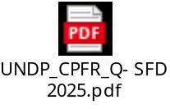

Appendices
Insert the latest approved Annual Work Plan (AWP), relevant copies of media coverage, publications, etc. Specific reporting requirements from donors can also be inserted here.

- SFD Multiyear work plan
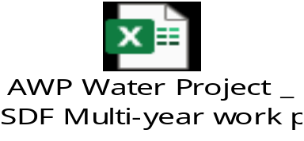

- Media coverage
https://x.com/UNDPSomalia/status/2011326916834324775
https://www.undp.org/somalia/stories/solar-powered-boreholes-bring-life-saving-water-drought-hit-communities-somalia
UNDP, Saudi Fund for Development partner to provide water to drought-affected communities in Somalia | United Nations Development Programme
(20) UNDP Somalia on X: "Somalia’s drought-hit communities to secure access to water with support from Saudi Fund for Development https://t.co/CJQx7h8hII https://t.co/AeeERmtGDh" / X

4. Drawings

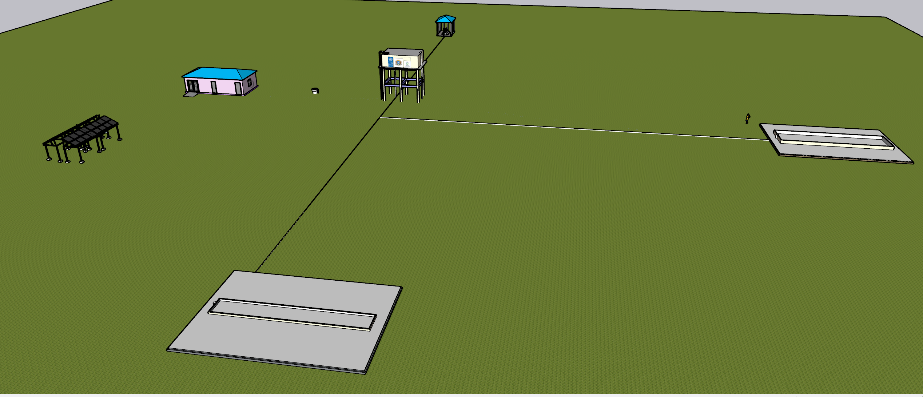
Drawing 01: Site layout showing Solar system, Office rooms, Kiosk, 2 animal troughs and Elevated water tank, courtesy to UNDP Somalia,

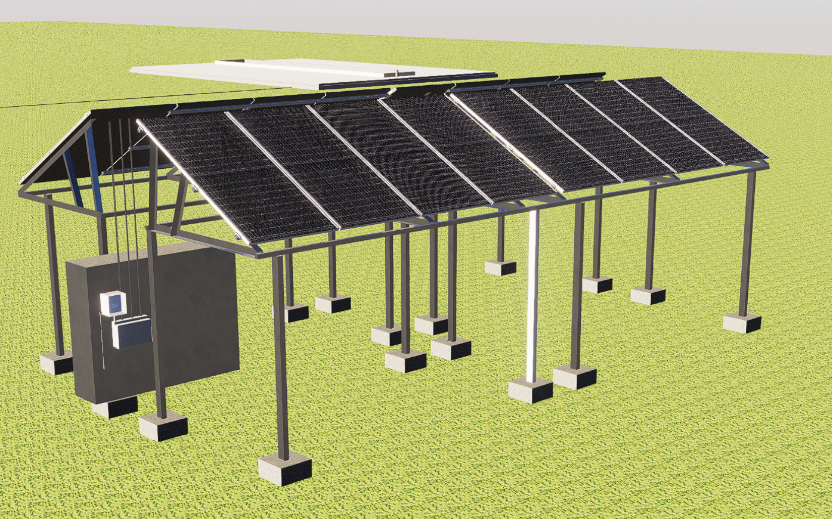
Drawing 02: Solar system 3D drawing, courtesy to UNDP Somalia

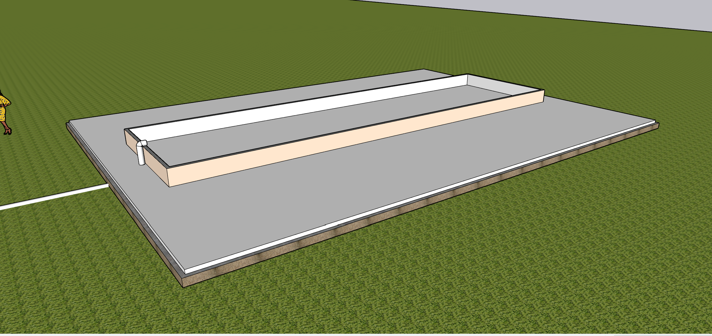
Drawing 03: Camel trough 3D drawing, courtesy to UNDP Somalia
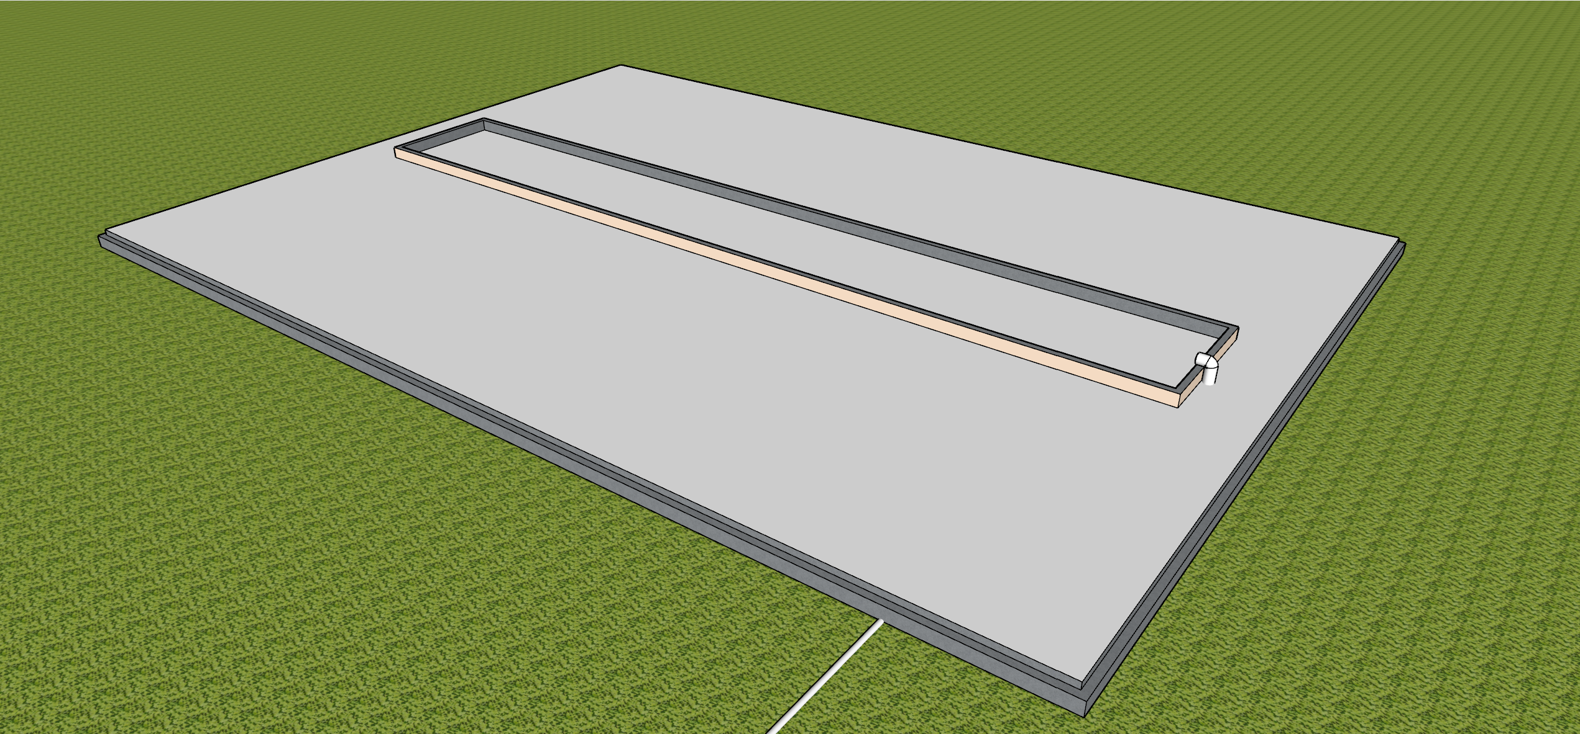
Drawing 04: Ship/goat trough 3D drawing, courtesy to UNDP Somalia

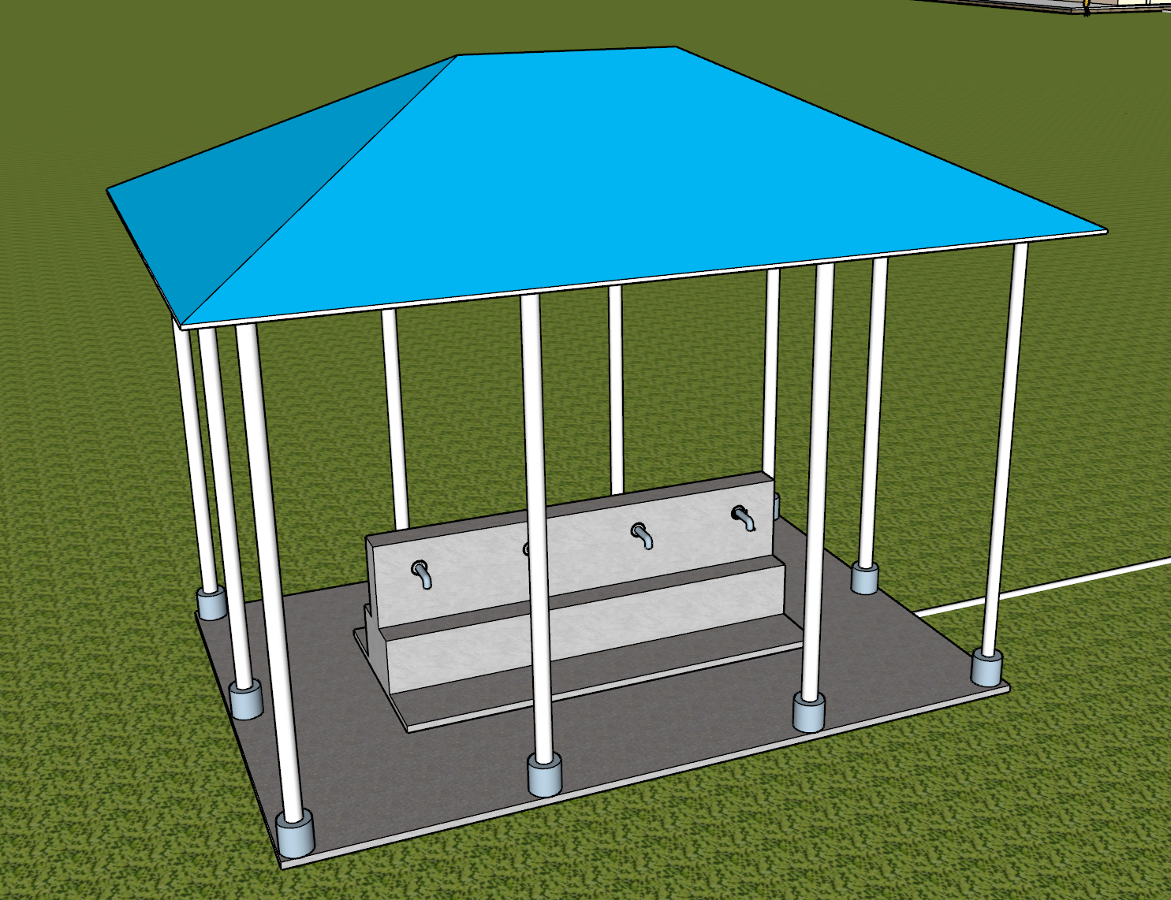
Drawing 05: Water kiosk drawing, courtesy to UNDP Somalia
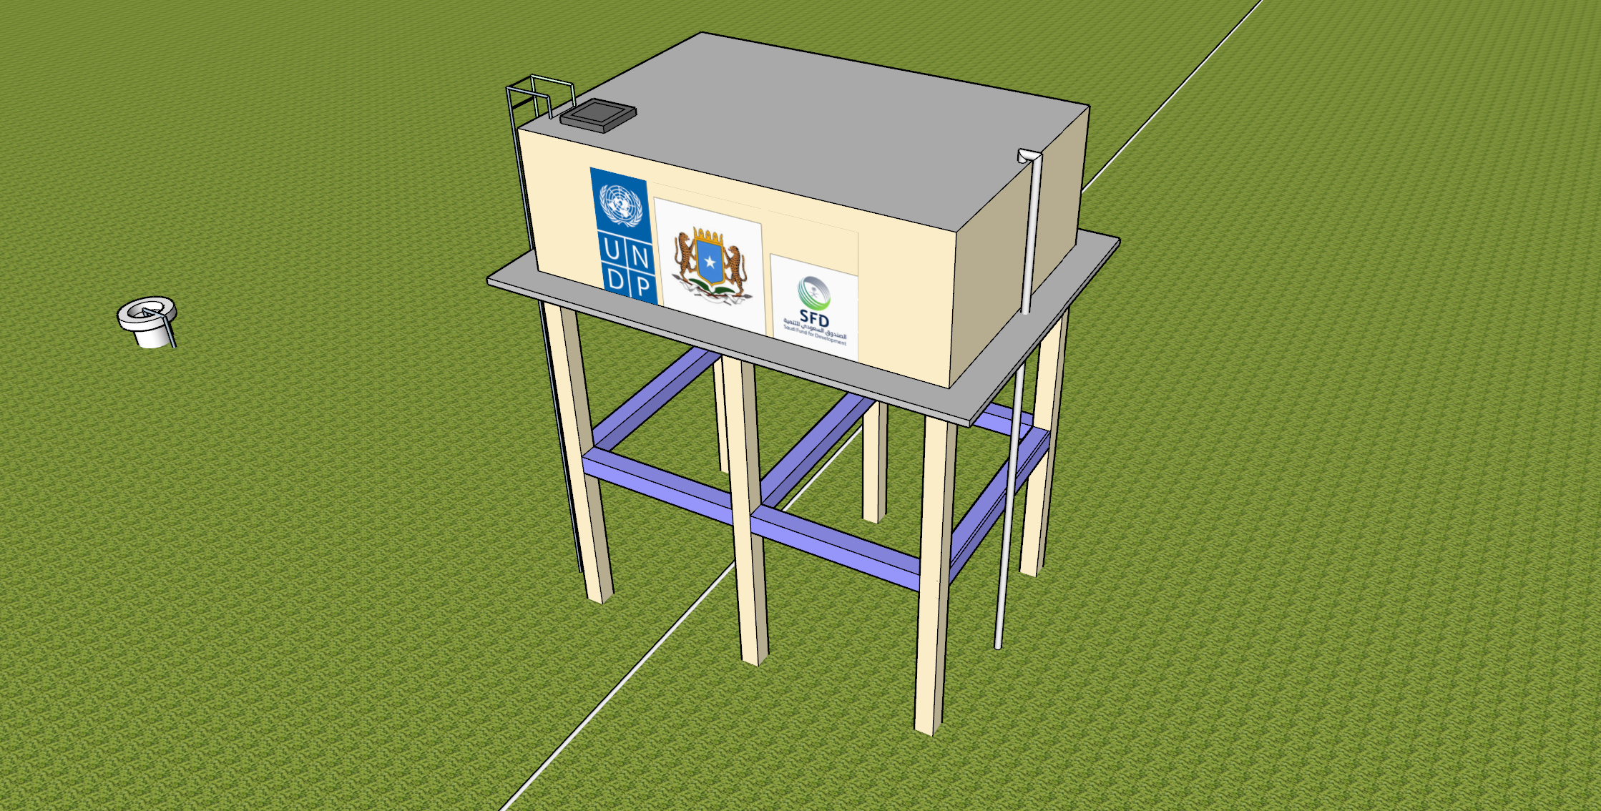
Drawing 06: Elevated water tank 3D drawing, courtesy to UNDP Somalia

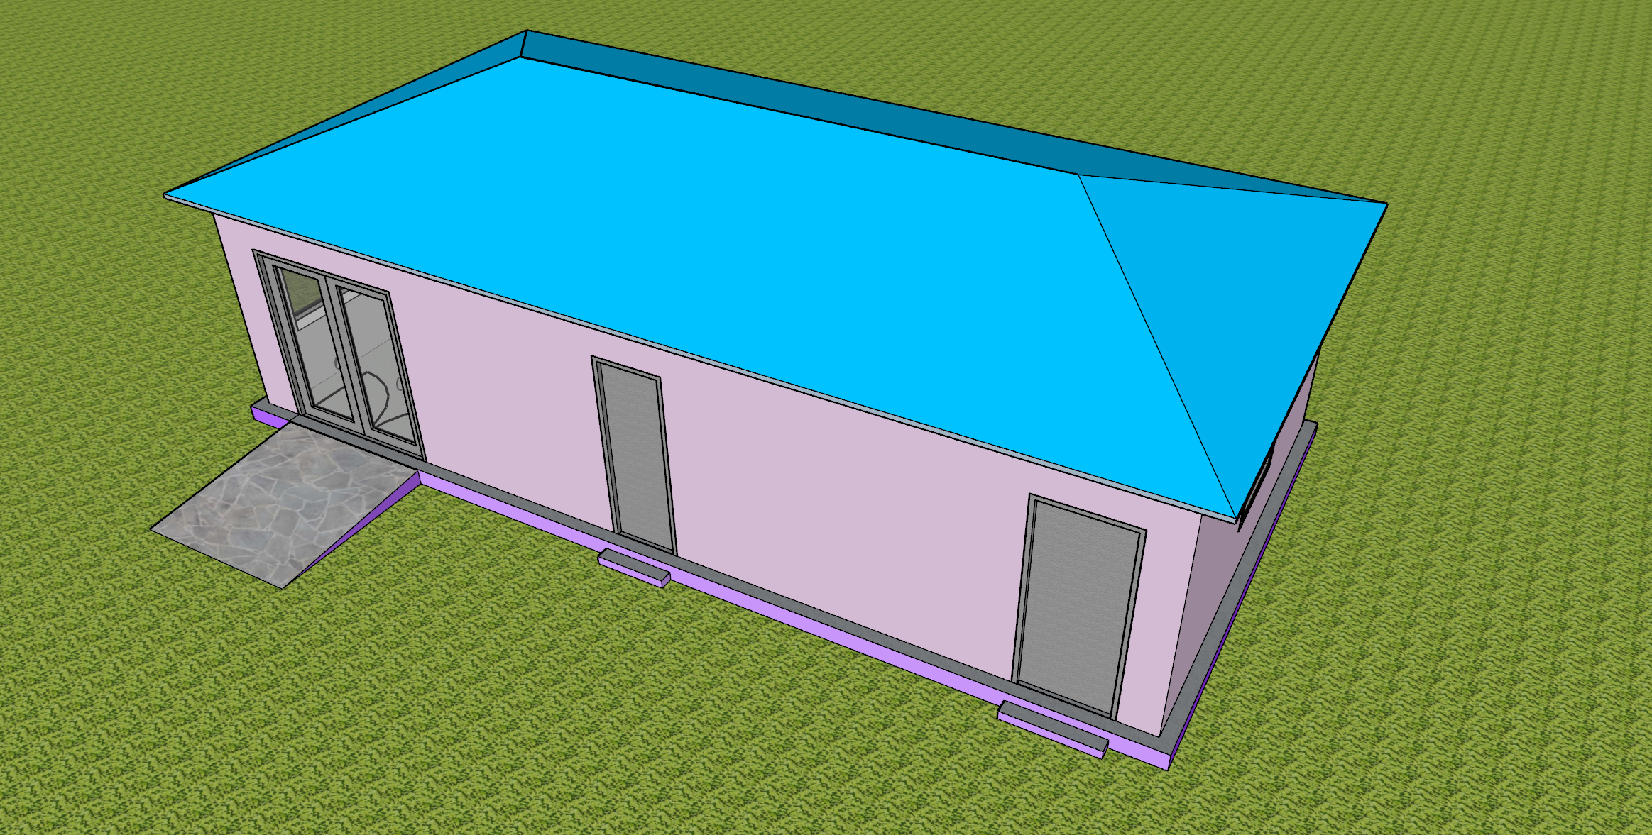
Drawing 07: Generator, store and office room , courtesy to UNDP Somalia

Water Resource User Associations established and trained
Table: Shangeed/Hagoogane WRUAs
SN | Name | Gender
1 | Maxamed Maxamuud Jaamac | M
2 | Iqbaal Sahal Cabdikariin | M
3 | Cabdikhadar Ibrahin Ducale | M
4 | Caqil Cabdirashiid Faracade | M
5 | Faadumo Yuusuf Axmed | F
6 | Bile Sulub Muuse | M
7 | Cabdiqadir Adan Maxamed | M

Table: Qararo WRUAs
SN | Name | Gender
1 | Husen Adan Caalin | M
2 | Mohamoud Hasan Warsame | M
3 | Khaliif Osman Yusuf | M
4 | Hasan Ducale Muse | M
5 | Jamac Mohamed Ismaciil | M
6 | Hasan Cali Nuur Obsiiye | M
7 | Sahra Saleban Mire | F
8 | Mohamed Caydiid Hasan | M
9 | Farax Mohamed Mohamud | F
10 | Jamal Cali Hersi Cabdi | M

Table: Bacadweyn WRUAs
SN | Nam | Gender
1 | Mursal Husen Nur | M
2 | Abdirisaq Muse | M
3 | Abdulqadir Axmed Ali | M
4 | Abdimalig Mohamed Aden | M
5 | Ayan Mohamed Ahmed | F
6 | Xalimo Abdullahi Geele | F

Table: Awrboogays WRUAs
SN | Name | Gender
 | Cali Xasan Cali | M
 | Cabdi Jaamac Cali | M
 | Maryan Jaamac Cabdi | F
 | Xasan Jaamac Ismaacil | M
 | Xaali Maxamud Faarax | F
 | Axmed Cabdi Aadan | M
 | Saleebaan Ibraahim Cilmi | M
 | Siciid Yuusuf Axmed | M
 | C/laahi Maxamed X. Aadan | M

Terms of Reference (ToR) for Borehole Water User Association (BWUA)
Background
Overview of the Borehole Project and Its Importance to the Community
A borehole was constructed in Bacadweyn village with support from Saudi Fund for Development (SFD) in 2025 to address water scarcity. It provides clean water for domestic, livestock, and agricultural use, easing the burden on women and children. To ensure its sustainability and equitable use, a Borehole Water User Association (BWUA) was established to manage operations, maintenance, and finances

Rationale for forming a Water User Association (WUA).
A WUA ensures the sustainable and fair management of community water resources like boreholes. It promotes local ownership, accountability, and regular maintenance, helping prevent system failures. The association also serves as a bridge between the community and external partners, improving access to support, training, and funding.

Relevant National Water Policies and Community Development Frameworks
The BWUA aligns with Somalia’s National Water Resource Strategy (2021–2025), which promotes sustainable, community-led water management. It also supports the Ninth National Development Plan (NDP-9), which emphasizes improved service delivery, poverty reduction, and resilience through local governance.

Objectives
Ensure sustainable management and equitable distribution of borehole water
The BWUA will implement systems to manage water use efficiently, maintain infrastructure regularly, and ensure fair access for all community members. This includes setting usage guidelines, monitoring consumption, and promoting conservation practices to protect the borehole as a long-term resource.

Promote community ownership and participation
The BWUA encourages active involvement of all community members in decision-making, planning, and management of the borehole. This fosters a sense of responsibility, strengthens transparency, and ensures that the water system reflects the needs and priorities of the people it serves.

Maintain infrastructure and ensure water quality standards
The BWUA will be responsible for the regular inspection, repair, and servicing of borehole components such as pumps, tanks, and solar systems. It will also implement measures to monitor and protect water quality, including hygiene practices around the borehole, periodic water testing, and community education on safe water use

Scope of Work
Manage daily operations of the borehole and water distribution
The BWUA will oversee the routine functioning of the borehole, including regulating water access times, supervising water collection points, and ensuring orderly distribution. It will also assign roles for caretakers or operators, maintain usage records, and address any operational issues promptly to ensure consistent service delivery

Collect user fees and manage finances transparently
The BWUA will establish a fair and affordable fee structure for water usage, ensuring all users contribute to the operation and maintenance of the borehole. It will maintain accurate financial records, issue receipts, and conduct regular financial reporting to the community. Funds will be deposited in a designated bank account, with clear procedures for withdrawals and oversight by elected signatories to promote transparency and accountability

Maintain infrastructure (e.g., pumps, tanks, solar systems)
The BWUA will ensure that all borehole infrastructure is regularly inspected, cleaned, and repaired as needed. This includes mechanical components like hand or submersible pumps, storage tanks, and any solar power systems. The association will develop a maintenance schedule, engage trained technicians when necessary, and allocate funds for spare parts and emergency repairs to prevent service interruptions.

Monitor water usage and quality
The BWUA will track daily water consumption to ensure fair distribution and identify any unusual patterns that may indicate leaks or misuse. It will also implement regular water quality checks, either through visual inspection or laboratory testing—to ensure the water remains safe for drinking and domestic use. Community members will be educated on hygiene practices to help maintain water safety at the source.

Resolve disputes among users
The BWUA will establish fair and transparent procedures for resolving conflicts related to water access, usage schedules, or fee payments. A designated committee or trusted community members will mediate disputes, ensuring that all parties are heard and that resolutions are guided by agreed-upon rules and community values. This helps maintain harmony and trust among users.

Membership
Open to all households or institutions benefiting from the borehole
Membership in the BWUA is inclusive and available to every household, school, health center, or other institution that relies on the borehole for water. This ensures broad community representation, encourages shared responsibility, and strengthens collective decision-making in managing the water resource.

Membership Criteria, Rights, and Responsibilities
Membership in the BWUA is open to all individuals or institutions that directly benefit from the borehole. To become a member, individuals must register with the association and agree to abide by its rules and regulations.

Rights of Members
- Access to borehole water according to agreed schedules and rules.
- Participation in meetings and decision-making processes.
- The right to vote and be elected to leadership positions within the association.

Responsibilities of Members
- Timely payment of water usage fees or contributions.
- Participation in community clean-up and maintenance activities.
- Respecting water usage rules and promoting responsible use among others.
- Reporting faults, misuse, or disputes to the BWUA leadership.

Election or Appointment of Executive Committee Members
The BWUA will establish a leadership structure composed of elected or appointed members, including a Chairperson, Secretary, Treasurer, and other relevant roles. Elections shall be conducted democratically, with all registered members eligible to vote and stand for office. The process will be transparent and held at regular intervals, typically every two to three years. In cases where appointments are necessary (e.g., due to resignation or vacancy), the committee may nominate candidates subject to community approval.5. Governance Structure

Roles and Responsibilities of the Executive Committee
Chairperson
- Provides overall leadership and direction for the BWUA.
- Presides over meetings and ensures decisions are implemented.
- Represents the association in external engagements with partners, government, or donors.
- Oversees conflict resolution and ensures transparency in operations.
Secretary
- Maintains accurate records of meetings, decisions, and correspondence.
- Prepares meeting agendas and circulates notices to members.
- Keeps membership records and ensures proper documentation of association activities.
- Assists in preparing reports and communication materials.
Treasurer
- Manages the association’s finances, including fee collection and expenditures.
- Maintains financial records and prepares regular financial reports.
- Ensure funds are deposited in the association’s bank account and disbursed according to approved budgets.
- Works with auditors or finance committees to ensure accountability.
Operations and Maintenance Officer (optional role)
- Oversee the technical functioning of the borehole and related infrastructure.
- Coordinates routine maintenance and emergency repairs.
- Keeps records of maintenance schedules and service providers.
Community Liaison Officer (optional role)
- Engage with community members to gather feedback and promote participation.
- Leads awareness campaigns on water conservation and hygiene.
- Supports conflict resolution and inclusion of marginalized groups.

Frequency of Meetings (Monthly, Quarterly)
The BWUA executive committee shall hold monthly meetings to review operations, address emerging issues, and plan upcoming activities. In addition, quarterly general meetings will be held with all members to present financial reports, discuss major decisions, and gather community feedback. Emergency meetings may be called when urgent matters arise.

Decision-Making Processes (e.g., Voting, Consensus)
The BWUA will make decisions through a participatory and transparent process. For routine matters, decisions may be made by consensus among executive committee members. For major issues—such as changes to fee structures, infrastructure upgrades, or leadership elections—voting will be used. Each member has one vote, and decisions will be passed by a simple majority unless otherwise specified in the association’s bylaws. Quorum requirements must be met for any vote to be valid.

Financial Management
Fee Structure and Collection Methods
The BWUA will establish a fair and affordable fee structure based on household size, water usage, or a flat rate agreed upon by members. Fees may be collected daily, weekly, or monthly, depending on the community’s preference and capacity. Collection methods can include cash payments, mobile money transfers, or prepaid tokens. All payments will be recorded, and receipts issued to ensure transparency. Collected funds will be deposited into the association’s bank account and used strictly for operations, maintenance, and administrative costs.

Bank Account Management and Signatories
The BWUA will open and maintain a dedicated bank account in the association’s name to securely manage collected funds. The account will require at least two or three authorized signatories, typically the Chairperson, Treasurer, and Secretary—to approve any withdrawals or transactions. This multi-signatory system ensures transparency and prevents misuse of funds. All financial activities will be documented, and regular account statements will be reviewed during committee meetings and shared with members during general assemblies.
Budgeting, Expenditure, and Financial Reporting
The BWUA will prepare an annual budget outlining expected income (e.g., user fees) and planned expenditures (e.g., maintenance, repairs, administrative costs). All spending must align with the approved budget and be authorized by the executive committee.
The Treasurer will maintain detailed records of all financial transactions and prepare quarterly financial reports to be reviewed by the committee and shared with members during general meetings. An independent audit or internal review may be conducted annually to ensure accountability and transparency.

Capacity Building
Training for Members on Water Management, Finance, and Governance
To ensure effective and sustainable management of the borehole, the BWUA will facilitate regular training for its members. These sessions will cover essential topics such as

- Water management: including borehole operation, maintenance, and conservation practices.
- Financial management: focusing on budgeting, record-keeping, and transparent fee collection.
- Governance: covering leadership skills, conflict resolution, and participatory decision-making.
Training may be delivered by local authorities, NGOs, or technical experts, and will be tailored to the needs and literacy levels of the community.

Partnerships with NGOs or Government Agencies for Technical Support
The BWUA will actively seek partnerships with non-governmental organizations (NGOs), local government departments, and development agencies to enhance its technical capacity. These partners can provide support in areas such as borehole maintenance, water quality testing, financial training, and governance. Collaboration may also include access to tools, materials, and funding for infrastructure upgrades. Formal agreements or memoranda of understanding (MoUs) may be established to define roles and expectations.

Monitoring and Evaluation
Regular Reporting on Water Usage, Finances, and Maintenance
The BWUA will maintain accurate records and provide regular reports on key operational areas:
- Water usage: tracking daily or weekly consumption to monitor demand and detect irregularities.
- Finances: documenting income from user fees, expenditures, and account balances, with quarterly financial reports shared with members.
- Maintenance: logging all repairs, servicing, and inspections of the borehole and related infrastructure.
These reports will be reviewed during committee meetings and presented to the wider community during quarterly general assemblies to ensure transparency and accountability

Annual Audits and Community Feedback Mechanisms
The BWUA will conduct annual financial and operational audits to ensure transparency and accountability. These audits may be performed by an independent auditor or a trusted committee appointed by the members. Audit findings will be shared with the community during general meetings.
Additionally, the BWUA will establish feedback mechanisms such as suggestion boxes, community forums, or regular surveys to gather input from members. This feedback will help improve service delivery, address concerns, and strengthen trust between the leadership and the community.

Conflict Resolution
Procedures for handling disputes among members or with external parties
Informal Resolution: Encourage direct dialogue between parties, possibly with help from a respected community member.
Mediation: If unresolved, the Executive Committee facilitates a mediation session.
Formal Complaint: A written complaint is submitted if mediation fails, detailing the issue and desired outcome.
Investigation: A subcommittee investigates and reports within 14 days.
Hearing & Decision: A formal hearing is being held, and the Executive Committee is taking a decision.
Appeal: Dissatisfied parties can appeal to the General Assembly within 30 days.
External Disputes: If external, attempt mediation or refer to local authorities or legal channels.
Documentation & Enforcement: All steps are documented. Non-compliance may lead to penalties or suspension.

Legal and Policy Compliance
Adherence to National and Local Water Regulations
National Water Laws
  - Follow Somalia’s National Water Resource Strategy (NWRS) 2021–2025.
  - Apply principles of Integrated Water Resources Management (IWRM).
  - Ensure equitable and sustainable water access.
Local Government Regulations:
  - Register with local authorities.
  - Comply with municipal bylaws on water use, pricing, and infrastructure.
  - Coordinate with district water offices for oversight and support.
Compliance Requirements:
  - Keep accurate records of water use and finances.
  - Submit regular reports to authorities.
  - Participate in training and capacity-building programs.

BWUA Registration
Legal Recognition: BWUAs should register with local government or relevant ministries to gain legal status.
Required Documents
  - Constitution or Terms of Reference (ToR)
  - List of members and leadership
  - Founding meeting minutes
  - Proof of location
Where to Register: Local district offices or the Ministry of Energy and Water Resources.
Benefits:
  - Legal authority to operate and receive funding
  - Recognition by government and NGOs
  - Access to training and support

ToR Validity and Review
- The ToR is valid for a specified period (e.g., 3 years).
- It is subject to review and amendment by the association’s members.
- Amendments must follow the procedures outlined in the ToR, typically requiring two-thirds majority approval during a General Assembly meeting.

Disclaimer: Data contained in this financial report section is an extract of UNDP financial records. All financial provided above is provisional.

